|  |  |
| --- | --- |
|  | Programming Fundamentals  1 of 2 |
|  |  |
|  | **Luke Kelly**  High Integrity Software Engineer - BSc Hons Degree - DN1WD0003 - 25/29  Programming fundamentals - DN4MD0013 - 25/26 |

Table of Contents

Table of Contents 1

1. Analysis 3

1.1. Problem Definition 3

1.2. Assumptions and Constraints 3

1.3. Functional Requirements 4

1.4. Non-Functional Requirements 4

2. Design 5

2.1. Design Overview 5

2.2. High Level Requirements 5

2.2.1. UML class diagrams 5

2.3. Low Level Requirements 6

2.3.1. Program Control Flow Chart 6

2.3.2. Data Structure Designs 7

2.3.3. Data Validation 7

2.3.4. GUI wireframes 8

3. Implementation 9

3.1. Implementation Process 9

3.1.1. Decomposition of design to form GUI 9

3.1.2. GUI modelling 9

3.1.3. Professional Practice Reflection 9

3.2. Choice Of Resources 10

3.2.1. Language and IDE 10

3.2.2. Libraries 10

3.3. Paradigms 11

3.3.1. Event Driven Paradigm 11

3.3.2. Object Oriented Paradigm 12

3.3.3. Procedural Programming 12

3.4. Further Documentation 13

3.4.1. Code snippets against initial requirements. 13

3.4.2. Use of Abstraction and Modelling 13

3.4.3. Software Lifecycle Methodology 13

4. Testing and Debugging 14

4.1. Test Strategy 14

4.1.1. Functional Testing 14

4.1.2. Test results 16

4.2. Development Testing 34

4.3. Debugging techniques 37

4.4. Quality Control and Reliability 38

5. Evaluation and Reflection 39

5.1. Strengths of solution 39

5.2. Limitations of solution 39

5.3. Future improvements 39

6. Appendix 40

6.1. Appendix A – Stakeholder communications 40

6.1.1. Assignment Brief 40

6.2. Appendix B – Source Code(s) 41

6.2.1. Version control – GitHub repository 41

6.2.2. Version control – logs 41

6.2.3. Document Readme 41

6.2.4. PlantUML class diagram source code 41

6.3. Appendix C – GUI prototyping 41

6.4. Appendix D – Further Documentation 41

6.4.1. Code snippets against initial requirements. 41

6.4.2. Use of Abstraction and Modelling 41

6.4.3. Software Lifecycle Methodology 41

6.5. Appendix E – Textual Tables. 41

6.5.1. Requirement Tables 41

6.5.2. Validation tables 41

6.5.3. Testing Table 41

6.5.4. Test result tables 41

7. References 41

1. Analysis
   1. Problem Definition

Requirements have been decomposed from stakeholder input of a scenario brief provided by WSG (see appendix A**)**, highlighting the need for a reliable component management software. Daracan et al. (2020)identify paper-based records lead to an unclear picture of stock and increased risk of human error leading to waste and delayed replenishment, and as such demonstrate a software solution which I have studied to aid analysis and design.

The current process relies on manual tracking of components, resulting in the above issues, demonstrating the need for a system to accurately log stock, maintain operational logs, and proactively set replenishment thresholds, helping reduce waste and dependency on manual processes that impact reliability.

As WSG operates in high-integrity fields, the system must prioritise accuracy, traceability, data integrity and controlled access. Therefore the proposed system must be secure, maintainable, scalable and modular. As such validation, levels of access, data storage and such will be fully considered.

It is also important the solution complies with all regulatory requirements. GDPR explains the relevant legal aspects of data minimisation and security, it is important employee credentials are handled securely. GDPR (2018)

* 1. Assumptions and Constraints

The system will be a prototype and not intended to be a final product, however all best practices and methodologies used for a final system must be fully applied here, given the safety critical, and secure nature of the business.

The time to develop the system is relatively short, and as such the scope is explicitly linked to stakeholder requirements outlined in the brief and my research, however the prototype will be fully modular and maintainable, allowing for future improvements and alterations when required by the business.

The system will be developed using Python 3.11 due to its fast-prototyping ability and have dependencies on the libraries (see appendix B – readme.txt). It will be fully tested on a windows machine, which is the intended deployment OS in the company, it is recommended that the company tests the solution fully and maintains backups before using any other OS.

As this iteration is a prototype, although featuring a GUI to test the software under the event driven paradigm, the GUI will not be styled beyond positioning but will be fully functional. Furthermore, it is assumed that the system will be used on one machine, as cloud services will not be implemented at this prototype stage.

Version control is used throughout all stages of development, using git and is hosted on github. The full source code and GitHub link can be found in appendix B.

* 1. Functional Requirements

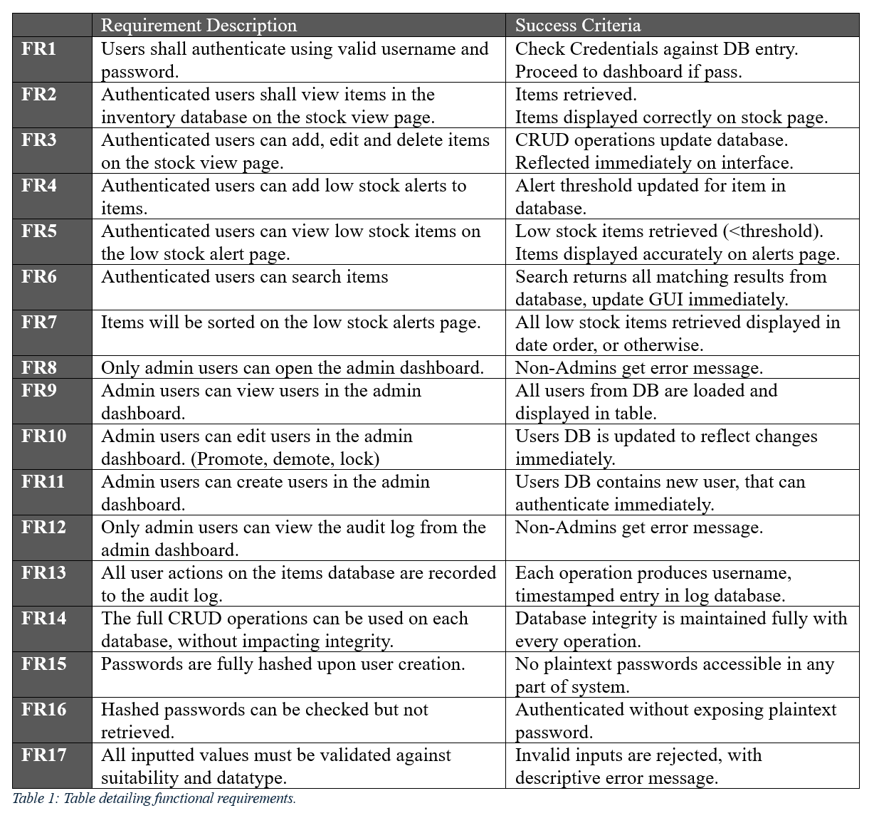

* 1. Non-Functional Requirements

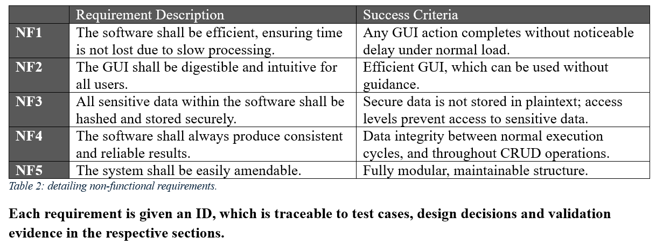

1. Design
   1. Design Overview

The system has been designed using a structured, modular architecture, including separate classes for each core function. This supports maintenance, scalability and testability by logically separating each core function, helping achieve Non-Functional Requirements NF4, NF5. The final code shall be thoroughly commented, with a focus on readability, data integrity and security as outlined in the requirements analysis.

* 1. High Level Requirements
     1. UML class diagrams

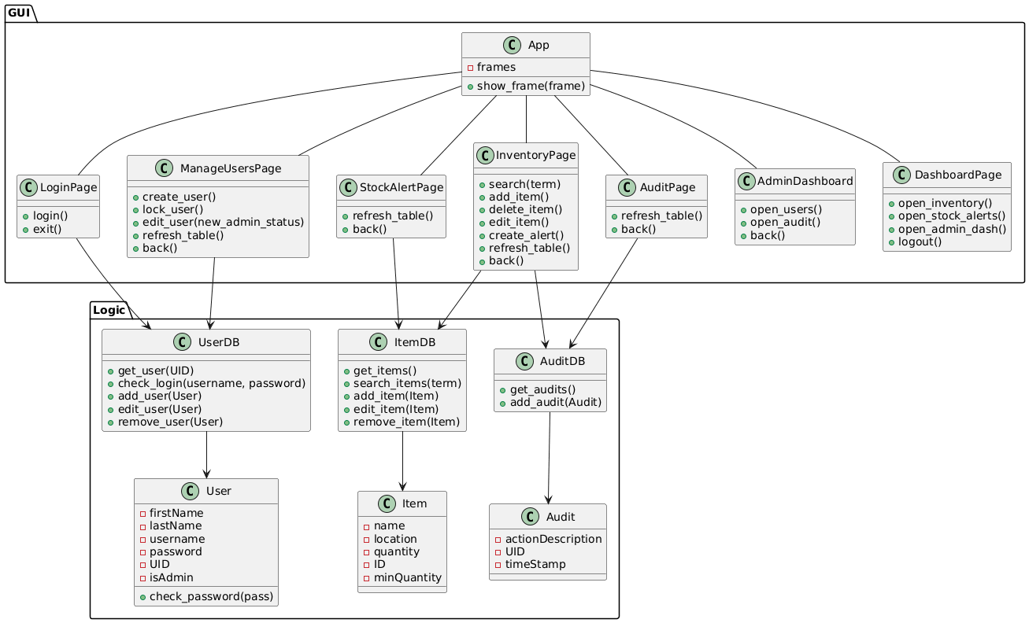

Figure : Proposed UML Class Diagram of inventory management system.

This HLR diagram was made using industry standard PlantUML language (See appendix B – source code).

The system architecture is divided into two primary layers, the GUI layer and the Logic layer, with relationships demonstrated on the diagram. This structure reinforces separation, supporting maintainability and scalability, this separation also supports testing, as unit tests can be easily carried out.

The GUI layer contains all foreseen classes to drive the UI, and event handling methods. Each class in this section represents a GUI page, with the exception of the ‘App’ class, which controls which page is displayed at any one time. This supports modular development, utilising the event driven paradigm to simplify debugging and future updates.

The Logic layer holds the data entity classes, and their associated classes for SQLite database logic. This separation follows industry standards, utilising the object-oriented approach to isolate data access logic supporting reusability and maintainability.

* 1. Low Level Requirements
     1. Program Control Flow Chart

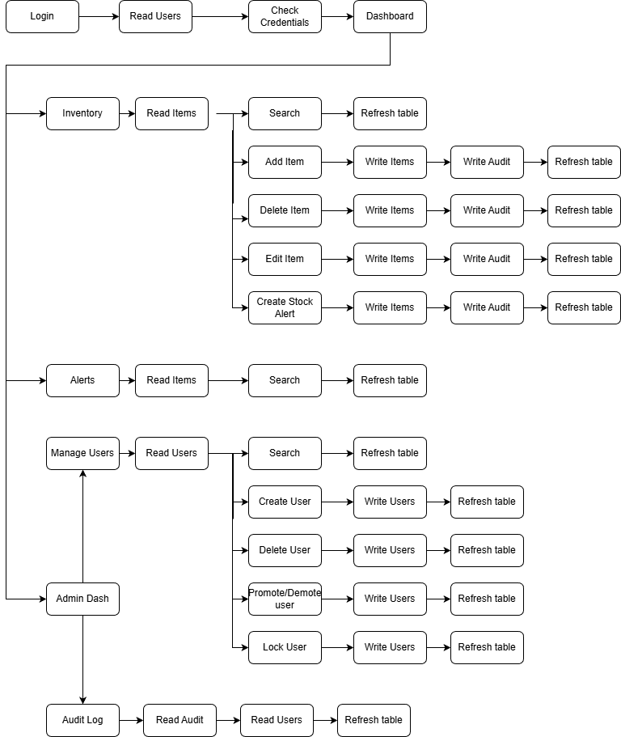



Figure 2: Program control-flow chart.

Figure 2 illustrates a breakdown of the overall program flow, showing how the end user will interact with the system from start to finish. The chart branches when the GUI has multiple options a user may select, creation of this diagram has supported considerations of usability and maintainability during the design and implementation stage.

This control flow, although utilising the event-driven paradigm, follows a predictable execution path, with set options per stage. This structured compartmentalisation of displays improves reliability, and maintainability, also allowing for easier unit testing in the testing stage.

Red asterisks have been added to key validation branches; error handling must be considered here to ensure a reliable solution with inputs to the database safely handled.

* + 1. Data Structure Designs

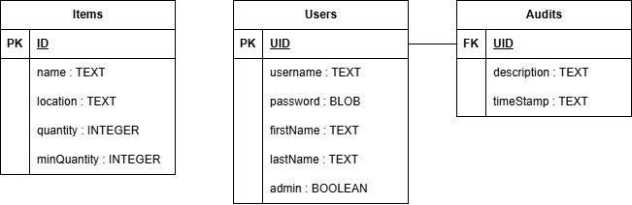

Figure 3: Proposed data structure design as Entity Relationship Diagram.

Figure 3 defines the proposed database structure, mirroring the object record structures we defined earlier. Users are linked to audits via the primary key of UID from the users table; this is a 1:M relationship. Each type shown here should be strictly reinforced by input validation, helping retain data integrity. Consideration was also given to this relationship in that user accounts may be deleted, for the prototype I have decided to “lock” accounts instead of deleting them, sustaining data integrity. I have also chosen SQLite for this database, which is detailed in the implementation section, due to this I have assigned the password field the BLOB type. Keeping with GDPR (2018) best practices, the passwords are stored as hashed binary, which must be stored exactly, and will not be erroneously transformed in a conversion to text.

* + 1. Data Validation

All validation occurs in the logic layer of the system, reinforcing the separation of concerns, allowing for easy addition of further data types in the future.

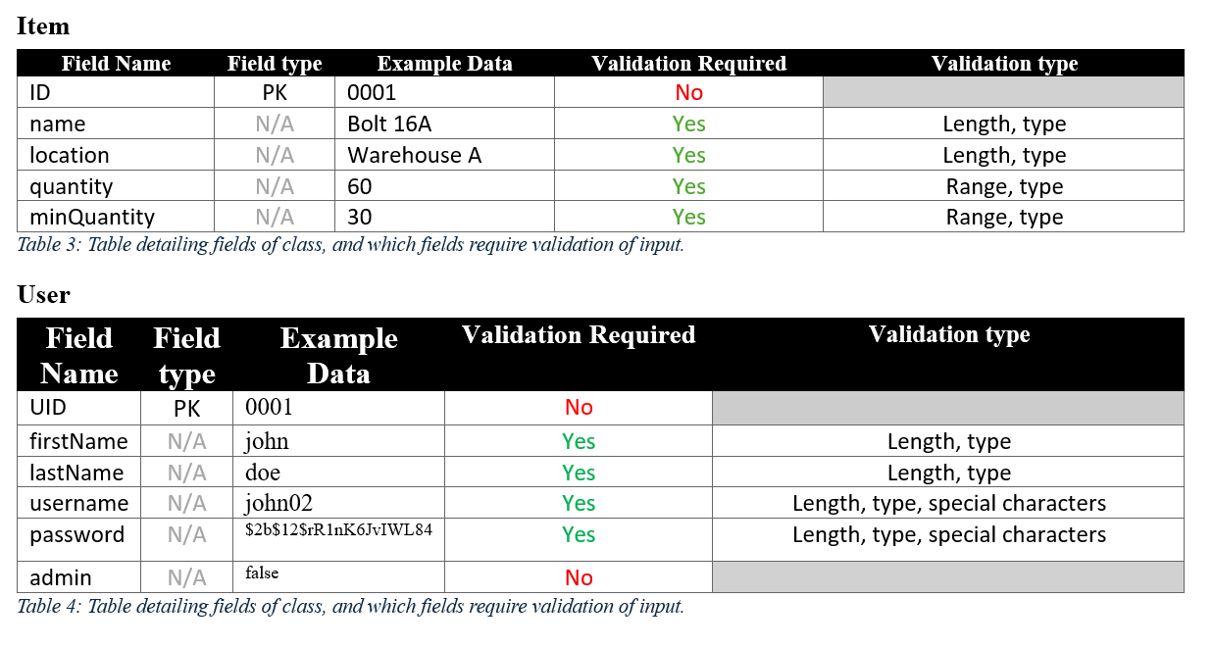

See appendix E for the textual version of these tables.

* + 1. GUI wireframes

Given pythons nature as a rapid prototyping language, and this application being a prototype, the GUI wireframing stage has been carried out in python, throughout the implementation stage. Each screen along with its popups is included in appendix C, demonstrating the link between the initial requirements and the final prototype GUI appearance, with validation and error handling.

1. Implementation
   1. Implementation Process
      1. Decomposition of design to form GUI

The system follows a layered architecture outlined in the design stage, separating components into GUI, Logic, and database layers to support maintainability. As such, I used the design documentation to first produce the GUI layer, before moving onto programming the logic and databases. Utilising the program flow, and assumed methods to decide button placements, table headings etc.

* + 1. GUI modelling

The produced GUI contains all user-facing components, in a single GUI.py file, with a separate class for each component. Each class encapsulates widget creation, event bindings, input validation and associated methods, creating separation between each window and its behaviours, preventing runtime conflicts like race conditions.

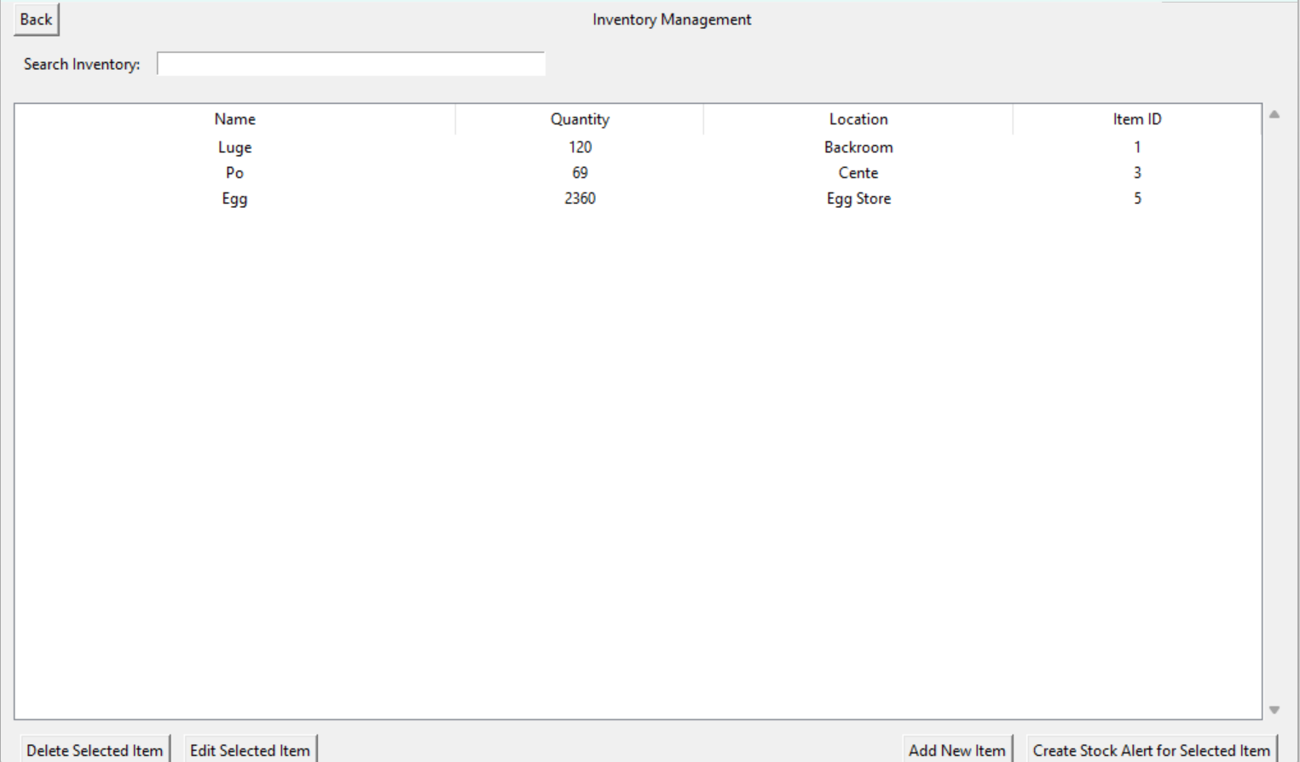

Figure 4: Example GUI model

**The full GUI model can be found in** **appendix C**

* + 1. Professional Practice Reflection

The layered architecture approach means that the GUI never directly interfaces with databases, and always does so through the logic layer, ensuring only small number of boilerplate methods are used, making maintenance easier as you only need to edit the method responsible for each function once, and helping ensure reliability through simpler testing. As such, this increased reliability reinforces data integrity, which is of upmost importance in an inventory management system, and was highlighted as a key point in the assignment brief provided by the company. Steps have also been taken to ensure the GUI is as intuitive and accessible as possible, while still considering the constraints outlined in section 1.2.

* 1. Choice Of Resources
     1. Language and IDE

The chosen language for this project is python 3.11 due to its wide library selection, providing well documented access to GUI and database libraries – an important factor in development of a system that will be used in high integrity contexts, as more commonly used libraries have increased reliability due to natural user testing through common use, and strong documentation which can help meet industry standard documentation requirements. Another reason python was selected is due to its support for OOP and event driven paradigms, it is also a rapid prototyping language, allowing fast iteration while maintaining readable and maintainable code to support future scalability. However, the GUI development is quite difficult to style in python as I did not use a GUI builder, this will be an opportunity to save time when I next create a prototype system.

The chosen IDE for this project was Visual Studio Code, due to its extensions library allowing easy view of databases, multiple modelling languages, alongside its debugging and testing features and native Git integration, maintaining version control logs as is industry professional standard. (see appendix B for repository).

* + 1. Libraries

Tkinter was chosen as the implementation library for the GUI, as it supports the event driven paradigm, providing simple visual widgets that display data and take input from users, a much more accessible and intuitive interface than the alternative of command line, due to the diverse audience that will come into contact with the system as outlined in the assignment brief. Tkinter is also natively supported by python, reducing risk in deployment due to extensive user testing as described in section 3.2.1.

Data handling uses the SQLite library. I chose SQLite due to its lightweight footprint, efficient performance and suitability for the prototype single machine deployment outlined in 1.1, while still following a structure that can be adapted for multi machine deployment in the future.

Passwords are secured using the bcrypt library, which automatically handles salting and hashing, providing a high level of resistance against brute-force attacks and ensuring sensitive credentials are never stored in plaintext, meeting GDPR and company policy.

* 1. Paradigms

A hybrid programming approach was used, combining object-oriented programming (OOP), event-driven programming, and procedural programming. This reflects professional industry programming practices to support maintainability, scalability, readability and reliability. These paradigms were selected over solely imperative programming, to prevent the use creation of monolithic code, which is not modular and as such hard to iterate upon post prototype and maintain.

My computational thinking was developed through use of the above paradigms, such as abstraction, decomposition and modelling.

* + 1. Event Driven Paradigm

The GUI was implemented using the event driven paradigm through the tkinter library. User interactions such as button navigations and text fields are all managed by this paradigm.

Yee et al. (2019) define event driven as a paradigm in which control flow follows an order of events. As opposed to sequential execution. In the system, GUI components act as event sources, event handler methods act as triggers to invoke logic.

The research explains that event handlers are invoked asynchronously. However, this leads to a level of complexity in the system that must be corrected for by the developer to prevent concurrency errors, like race conditions, which would counteract NF3 and NF4. While this asynchronous execution allows fluid and intuitive exploration of the interface, meeting NF2, I have enforced strong modulation between the GUI and logic layers, and use popups for major CRUD events, disallowing simultaneous interaction with the main GUI. These steps reduce the likelihood of unintended execution that affects data integrity and reliability.

Furthermore, this paradigm allows for a responsive application, without major resource overhead in continuous polling (as would be the case if using solely procedural programming with loops on a CLI). Each GUI page class also encapsulates its own event handlers, ensuring that logic is only triggered when required, increasing program efficiency further and helping modulate structure for simplified testing and debugging.

* + 1. Object Oriented Paradigm

Object Oriented Programming (OOP) was used throughout the system due to its suitability for modelling real-world entities, and reinforcing modularity as outlined in the brief, allowing for future extensibility when needing to add new objects.

Wegner (1990) describes classes as templates from which objects can be created. Inheritance is also explained as reusing the behaviour of a class in the definition of new classes, which I used in the GUI implementation for common features, on top of then adding class specific methods and attributes. This demonstrates my abstraction computational thinking.

Each entity is modelled into and object through their respective classes (User, Item, Audit), with each class encapsulating its own methods and attributes, which Wegner (1990) describes as a “separation of concerns”, helping split the large inventory system into components, which helps manage complexity – supporting reliability and scalability.

The database logic for each entity is also abstracted into dedicated classes (UserDB, ItemDB, AuditDB), creating a separation of concerns that prevents GUI components from directly executing database queries, improving security, and maintainability as explained in section 3.2.2.

Overall, OOP helps fulfil the stakeholder systems need by influencing a modular, reusable approach that supports maintainability, readability and scalability.

* + 1. Procedural Programming

Procedural programming techniques were utilised within each of the event driven classes methods to manage sequential stages such as input validation, authentication, CRUD operations and error handling.

Each code section utilising this paradigm follows a step-by-step execution path, making it easy to test, trace and debug. This flow is scoped within modular methods that are event driven to avoid monolithic logic.

* 1. Further Documentation

Further documentation including:

* + 1. Code snippets against initial requirements.
    2. Use of Abstraction and Modelling
    3. Software Lifecycle Methodology

Can be found in appendix D – Further Documentation

1. Testing and Debugging
   1. Test Strategy

I have been continually testing the systems throughout all stages of development, with development testing aiming to cover issues while working through the system implementation. Testing will focus on validating functional correctness, data integrity and reliability. To ensure traceability, test cases have been derived from the functional and nonfunctional requirements.

The following approaches were used:

* Unit testing of functions to verify error handling.
* Integration Testing of full workflows to ensure synergy.
* Validation Testing of typical, erroneous and extreme data.
* Load testing to ensure timely operation.

Debugging was supported through python exception trace messages, investigation through outputs, and stepping within the IDE.

* + 1. Functional Testing

The table is colour coded according to test type, each test # links to a test table, evidencing the actual result of the test.

* Typical data tests.
* Erroneous tests.
* Extreme tests.
* Load testing.
* Unit test.
* Integration test.

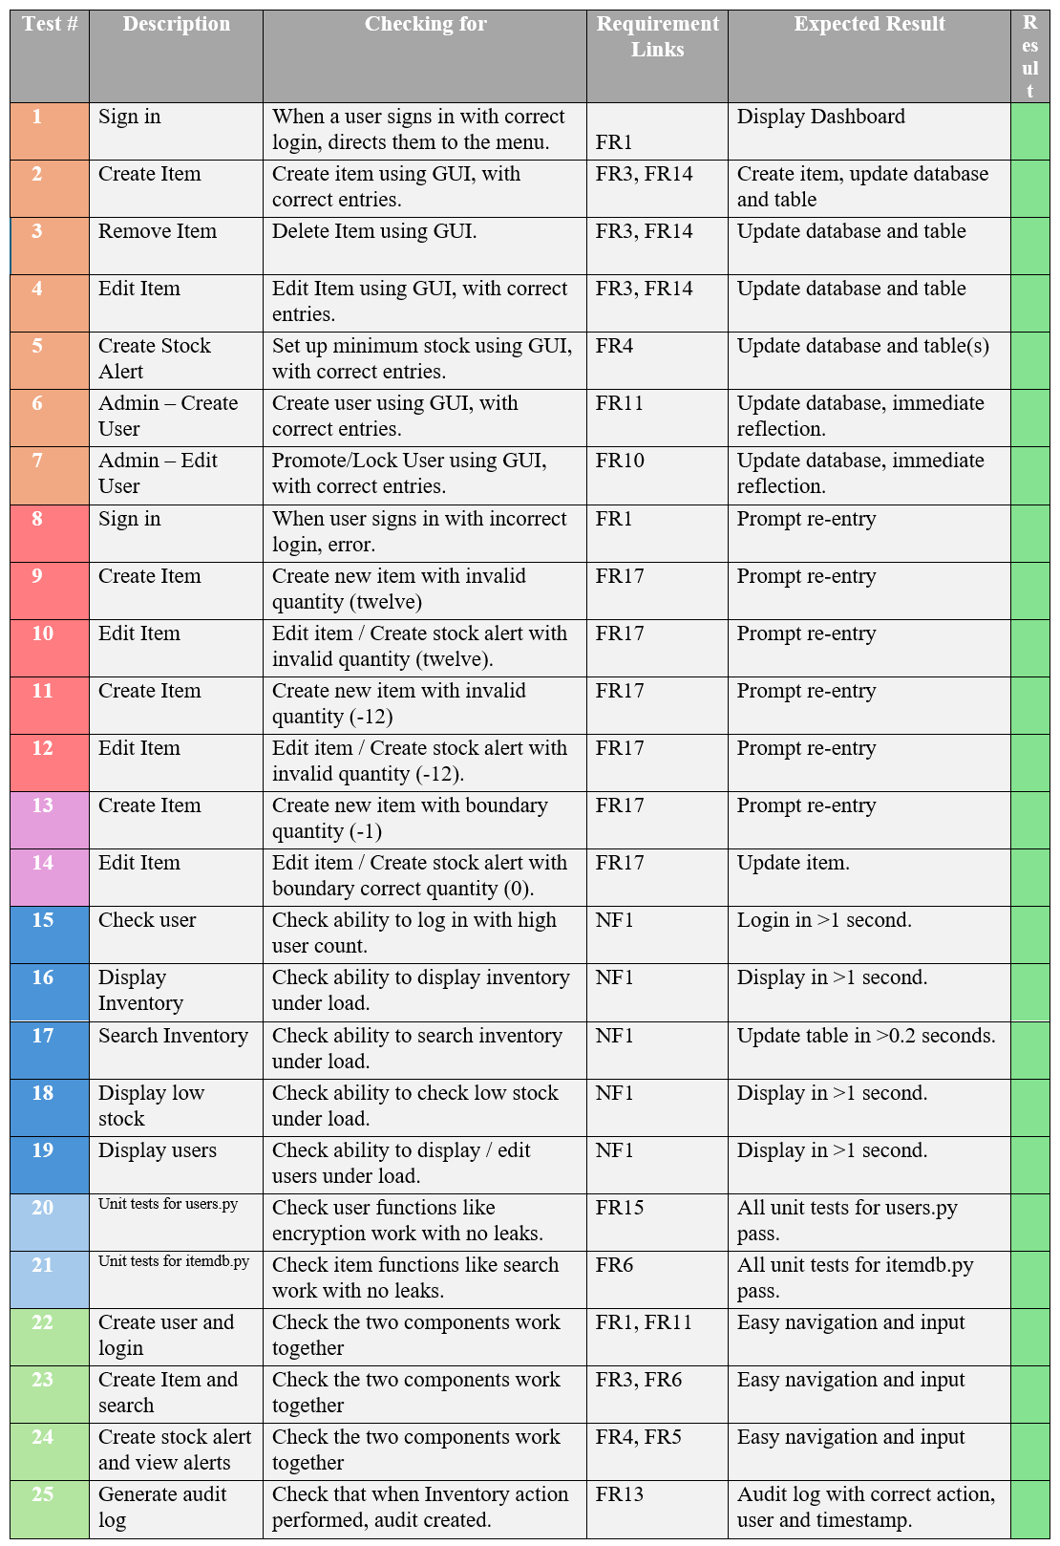Table : Detailing tests carried out, and their status.

These tests include validation testing, helping ensure system reliability by preventing erroneous data entry. Steps were also taken in development to research SQL injection and prevent against this.

* + 1. Test results

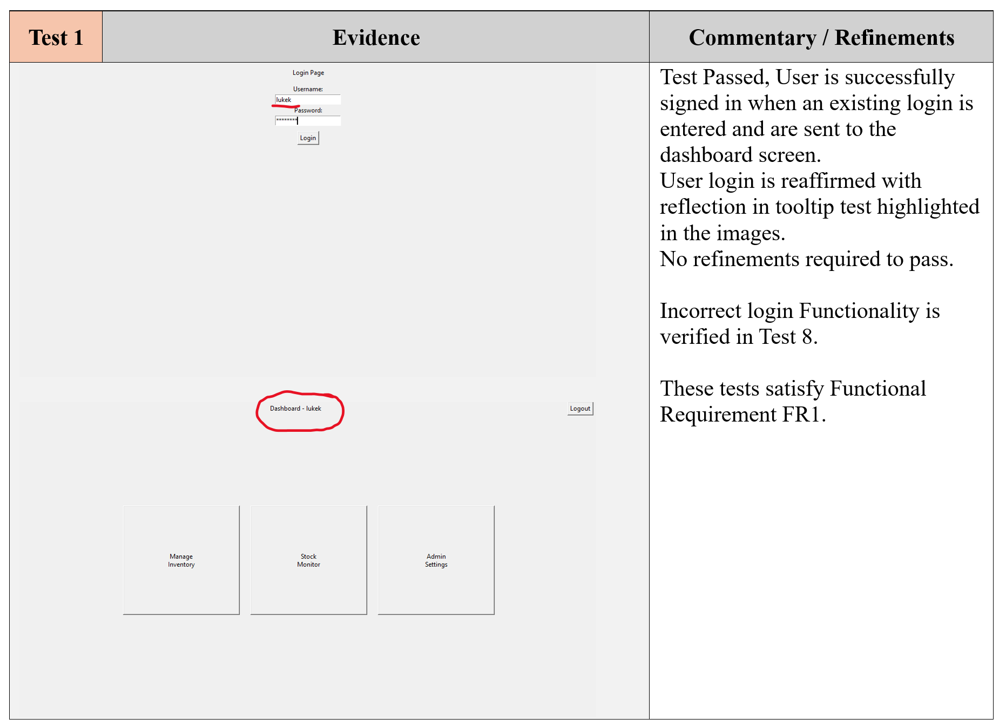

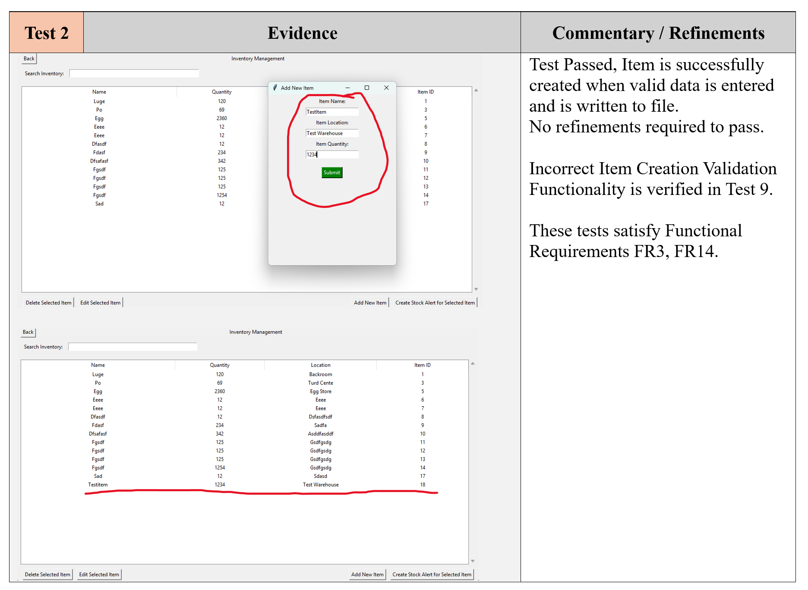

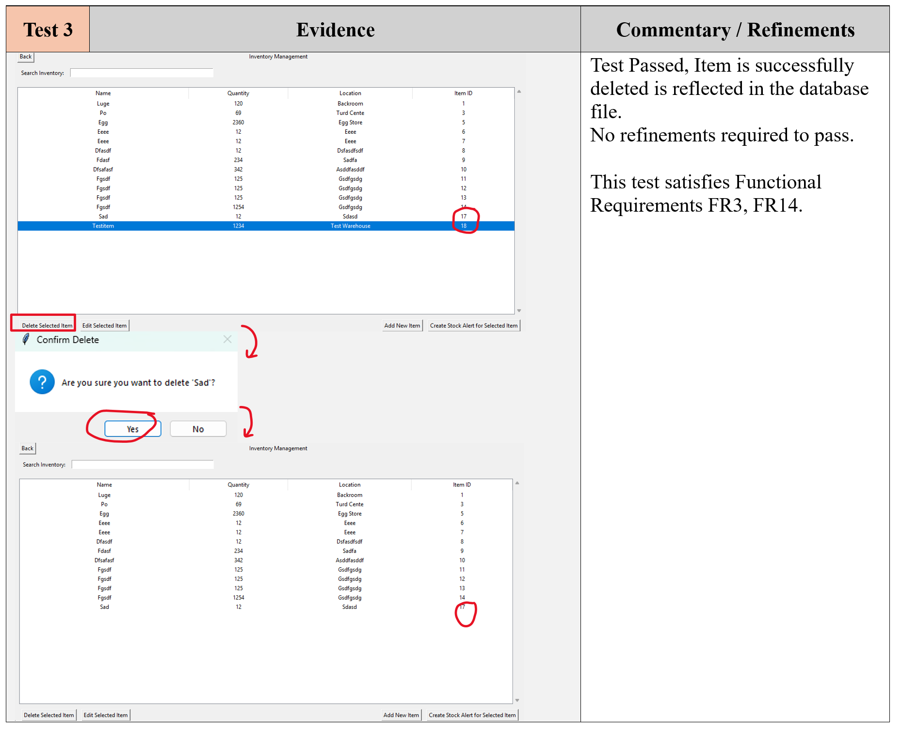

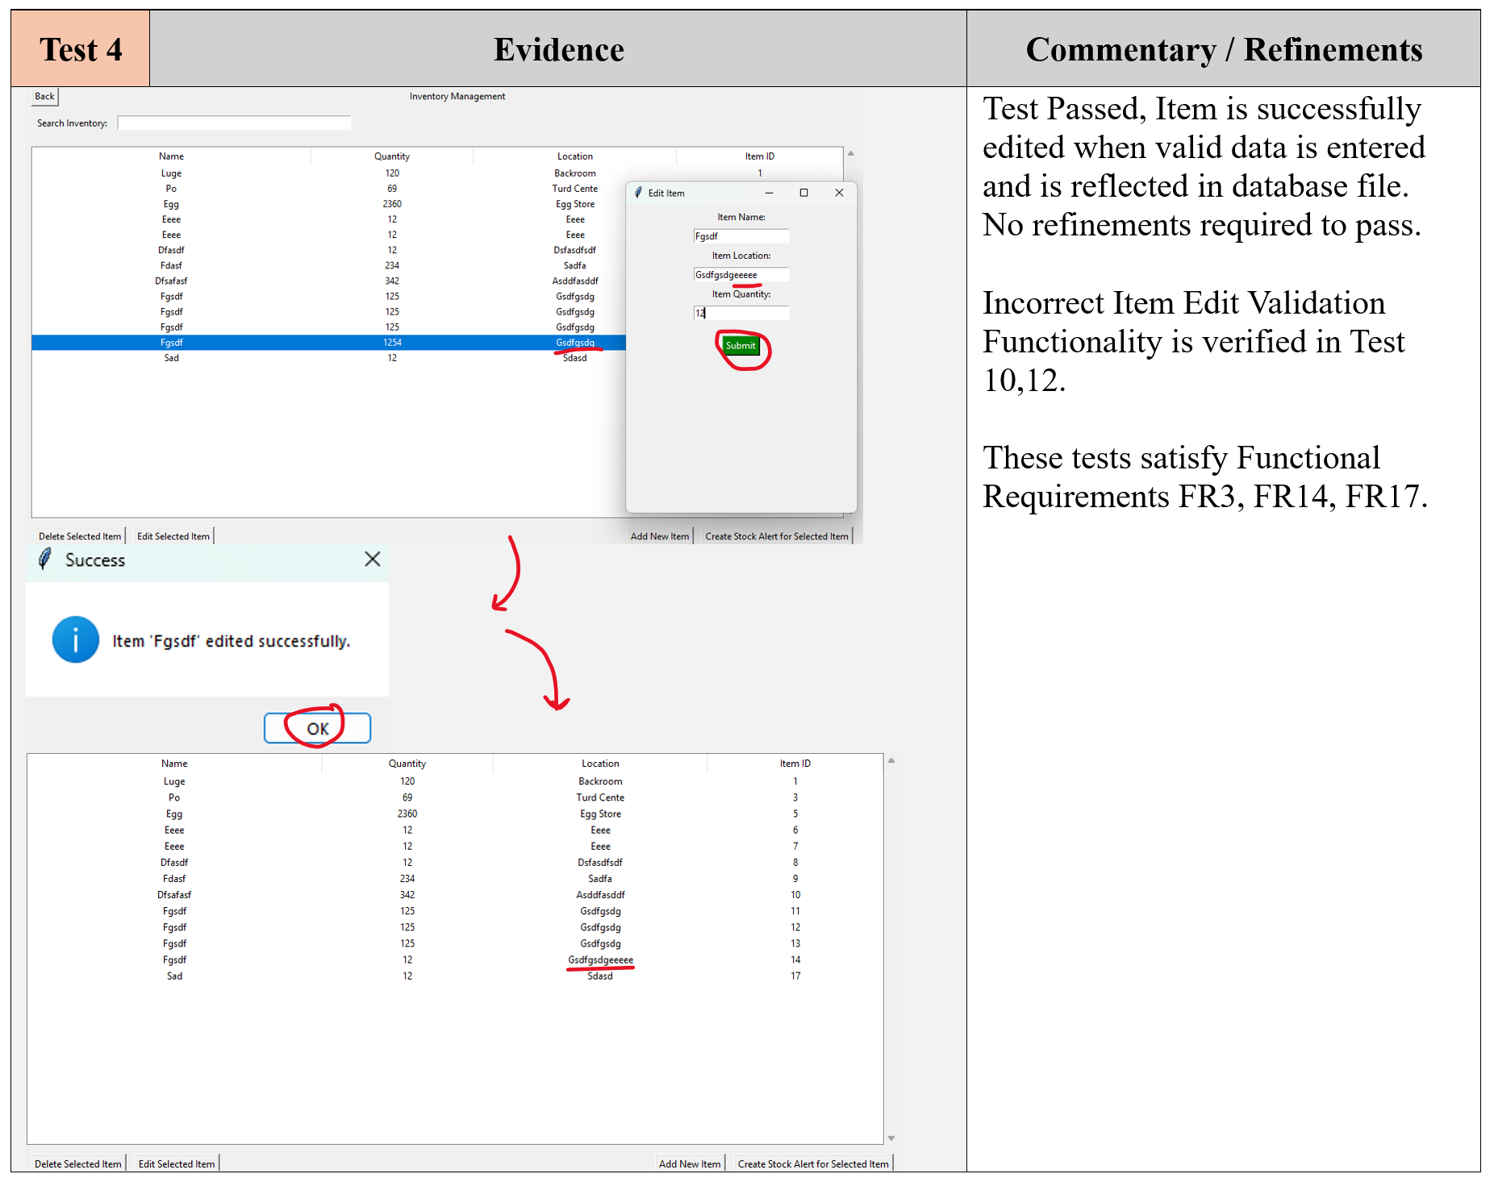

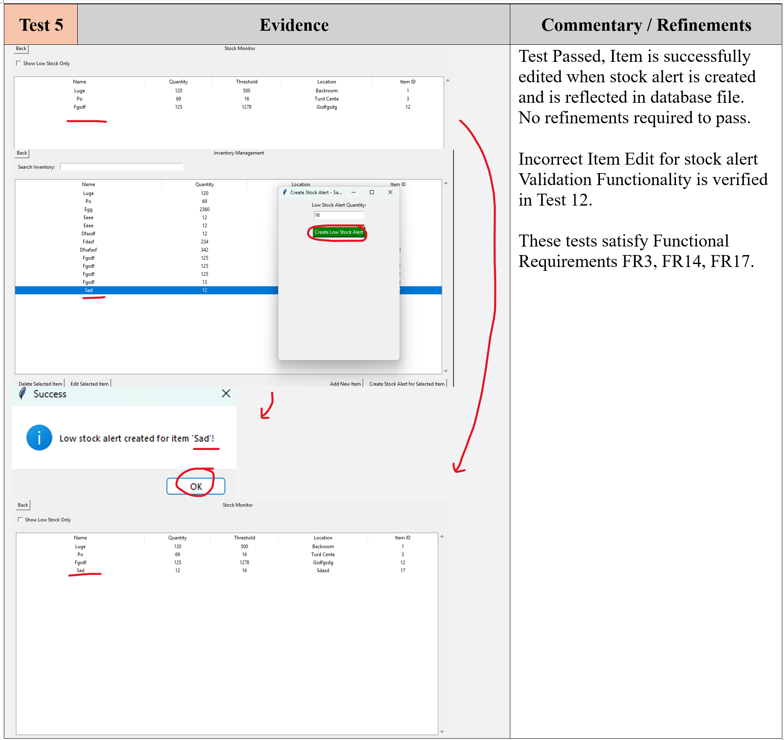

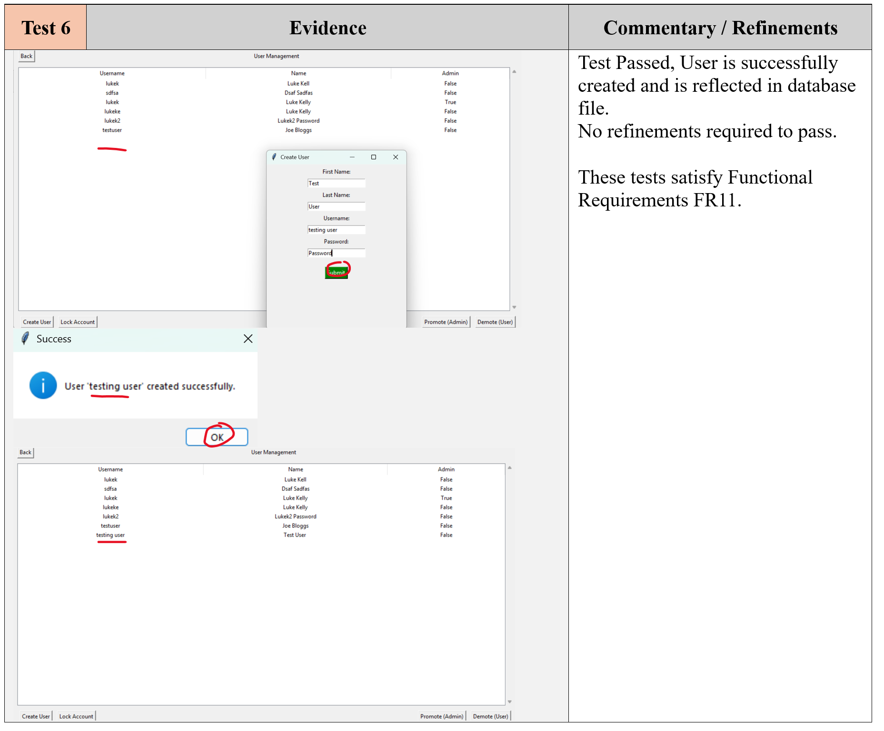

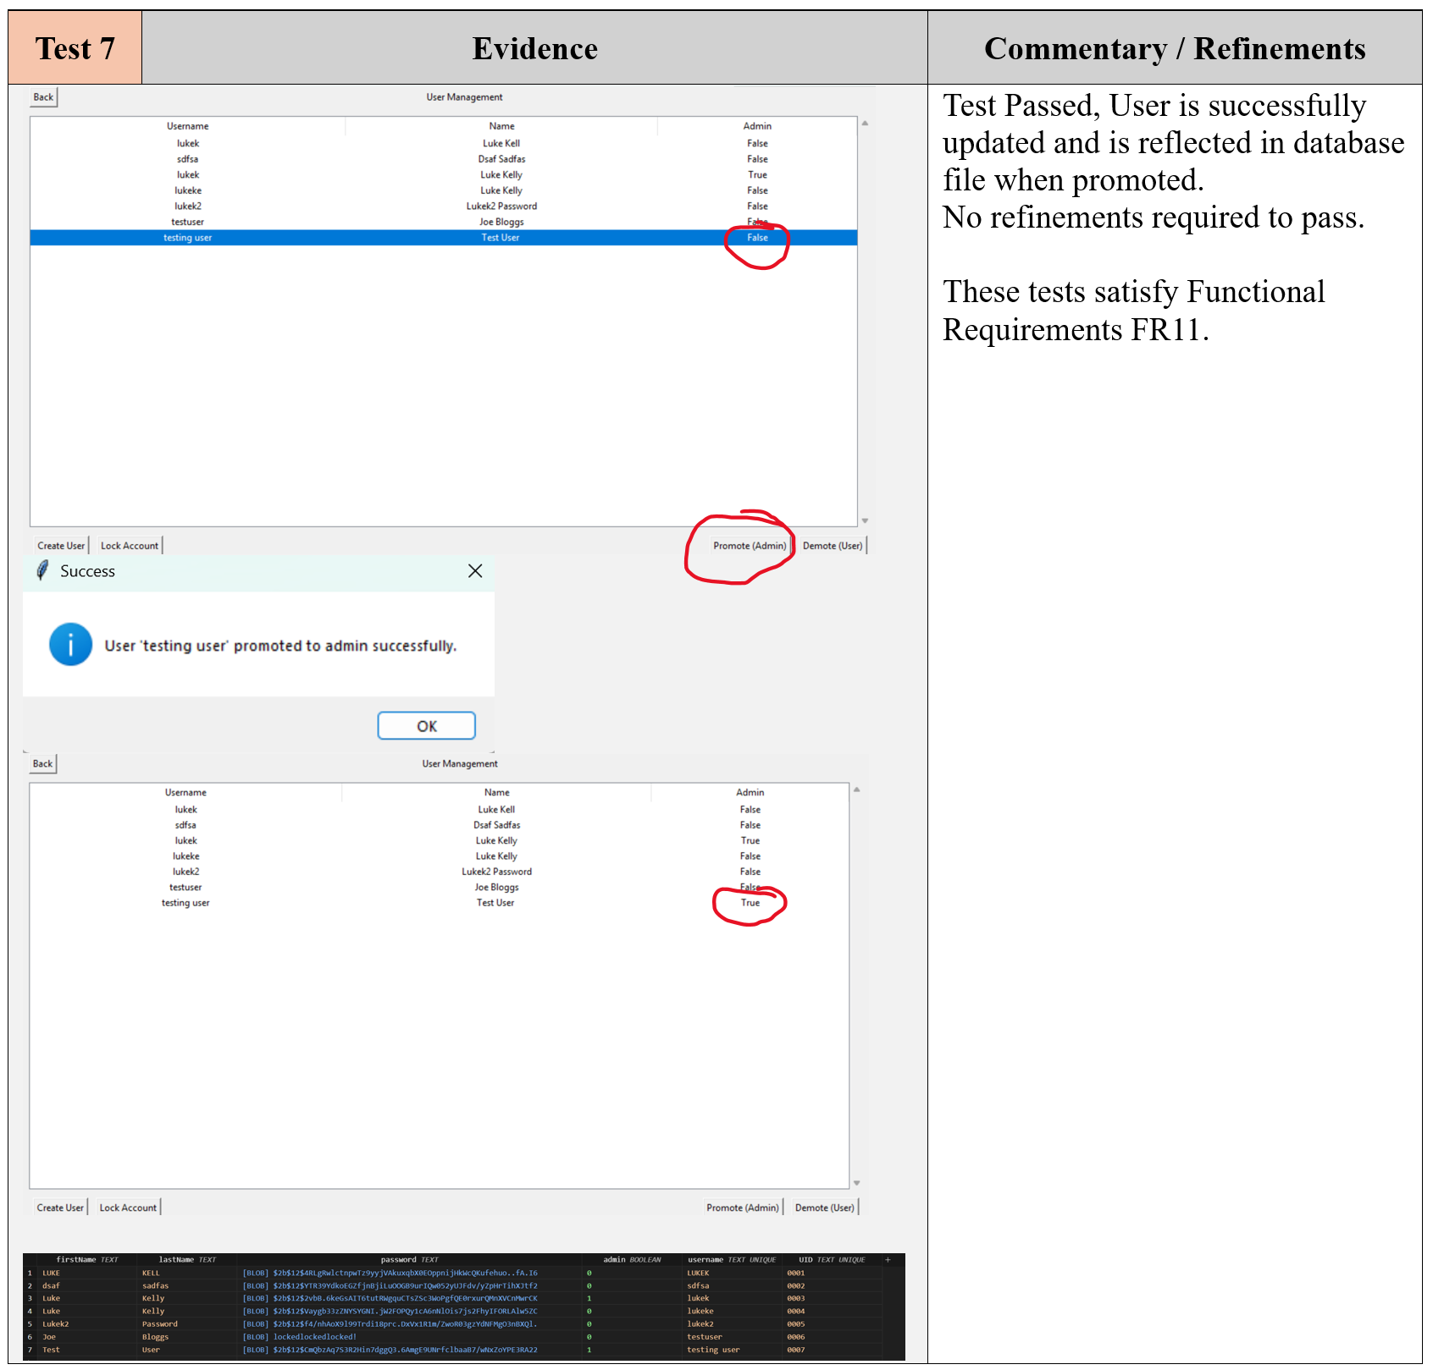

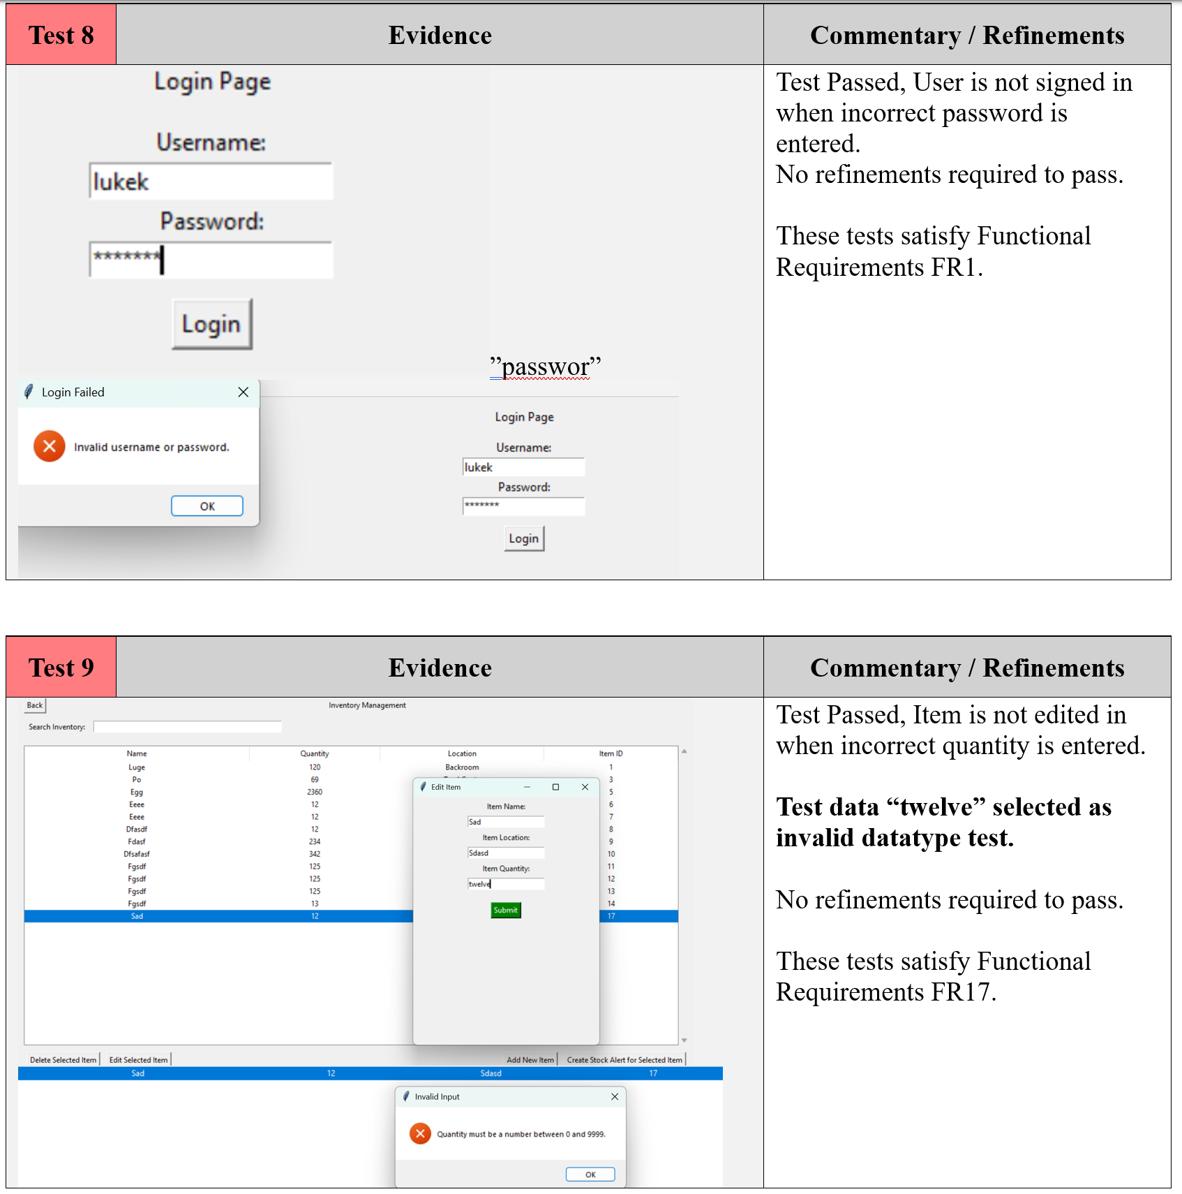

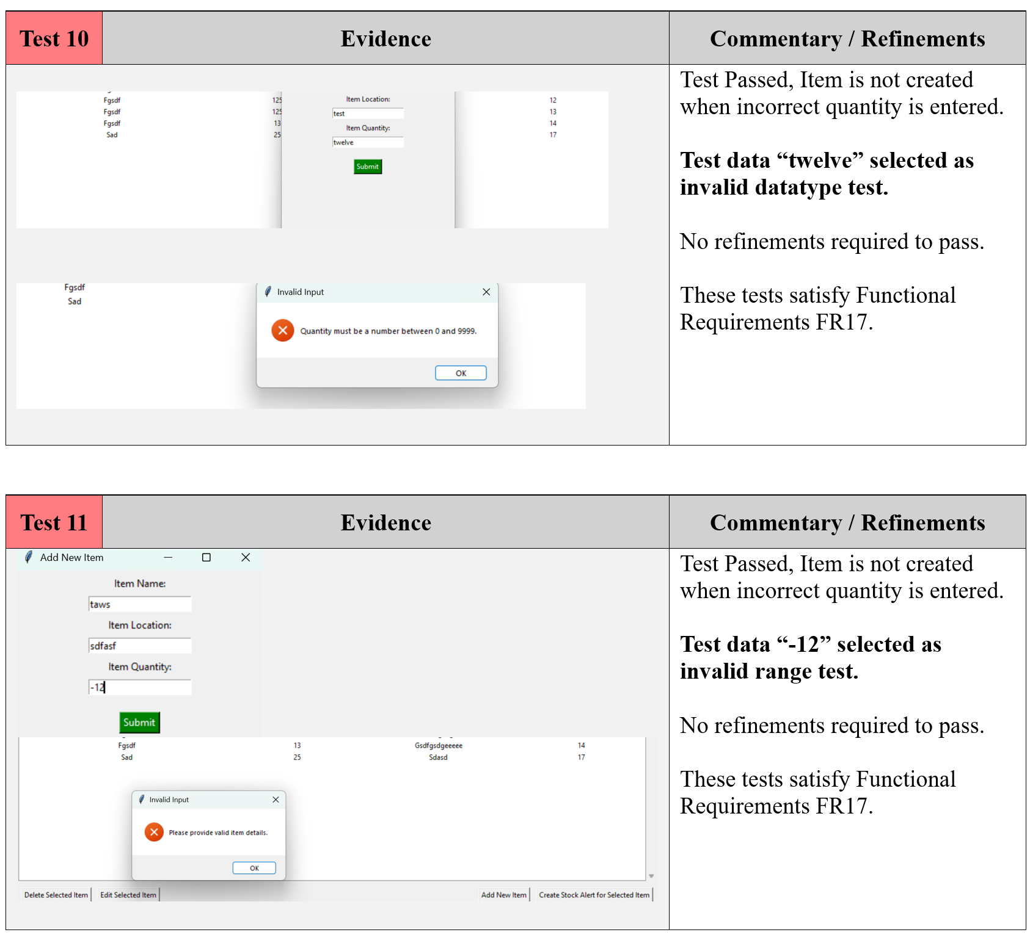

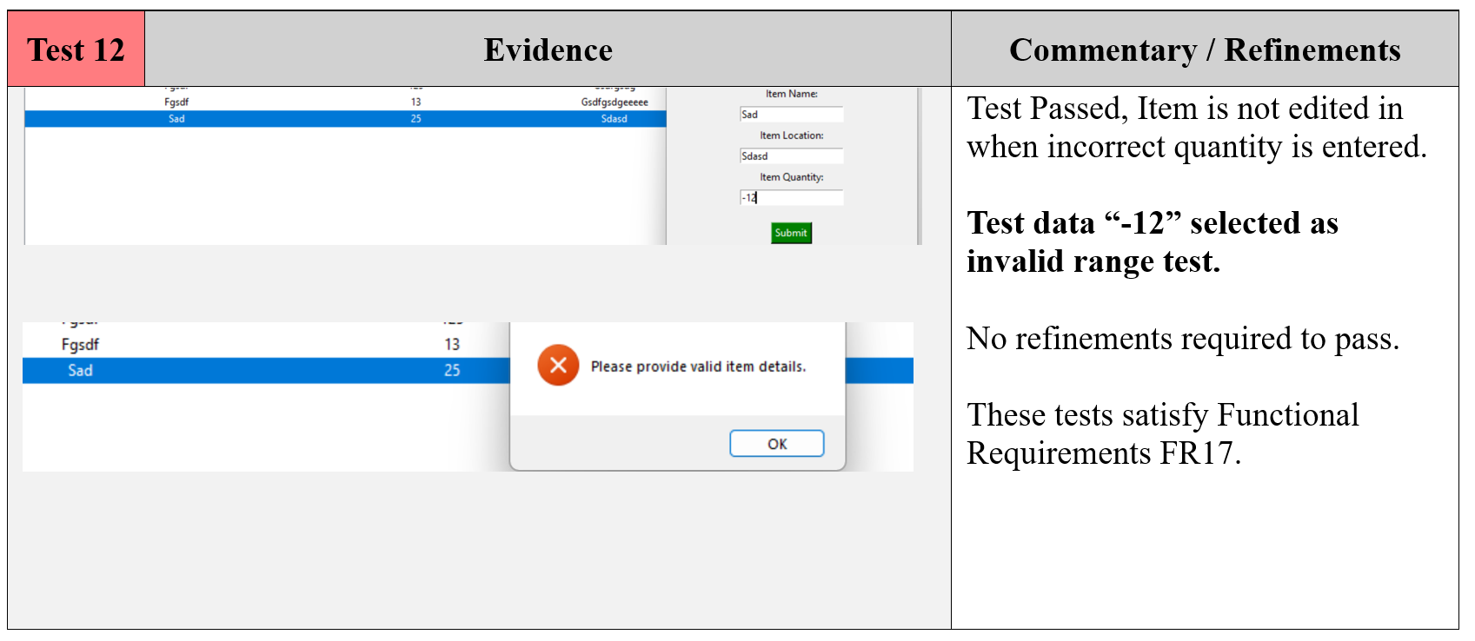

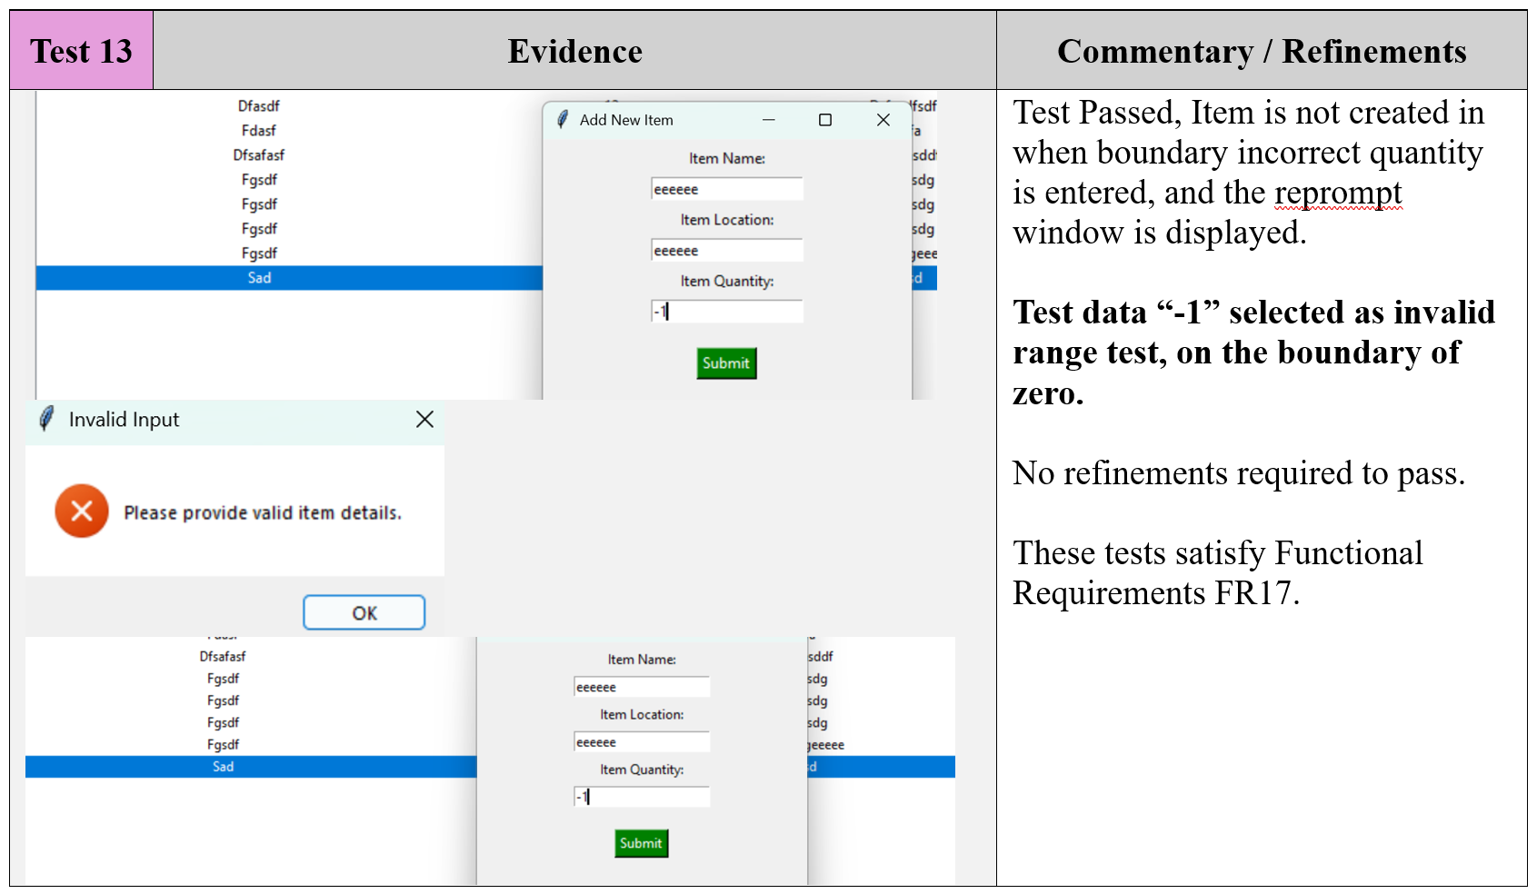

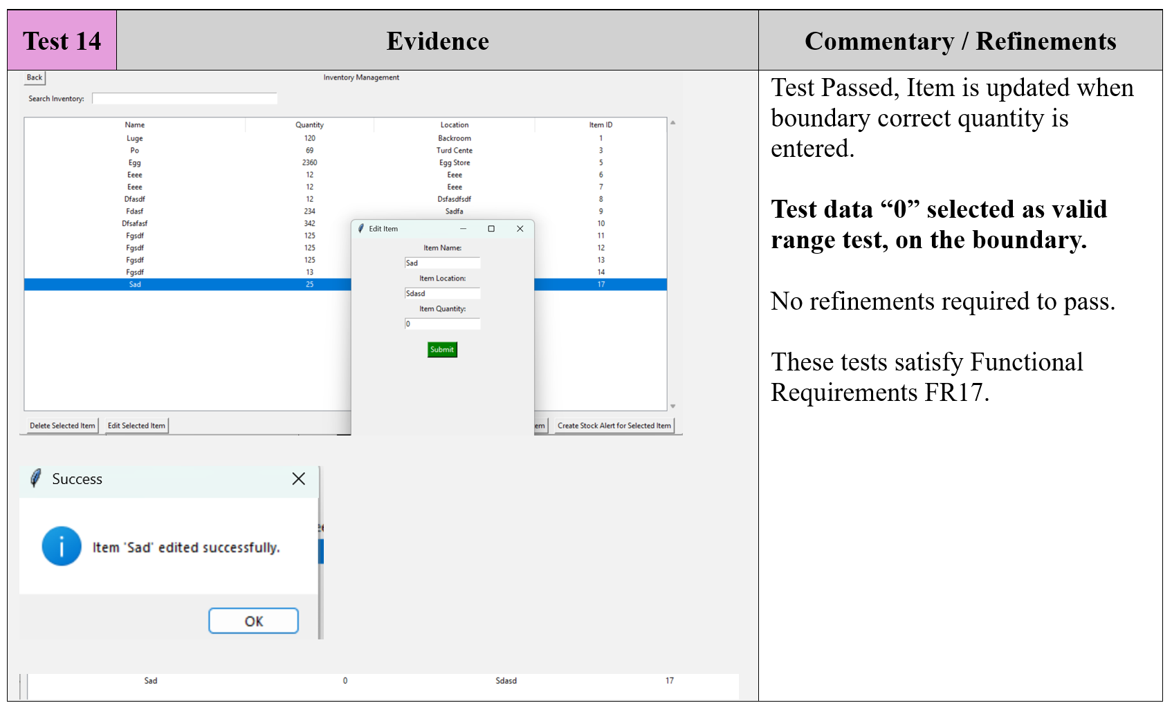

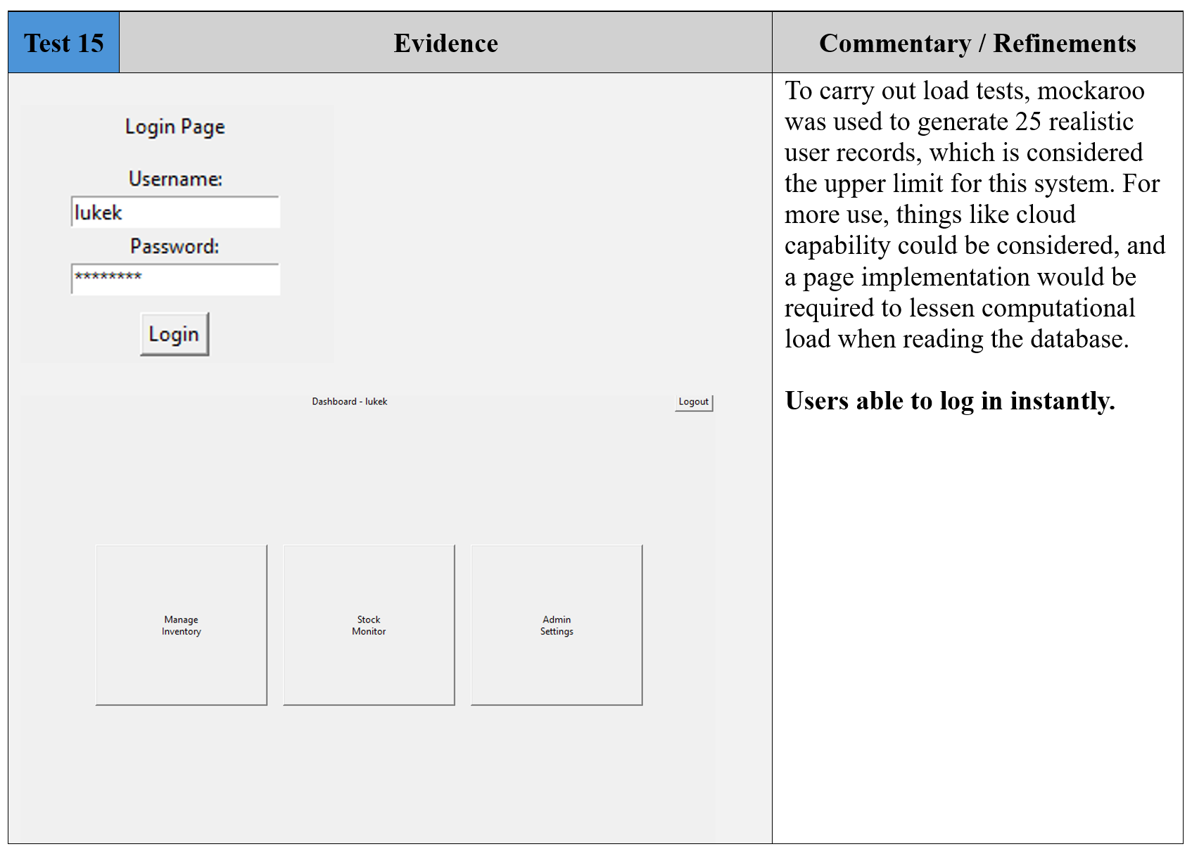

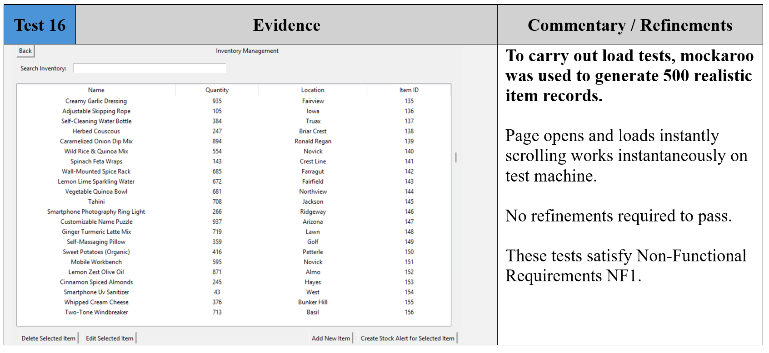

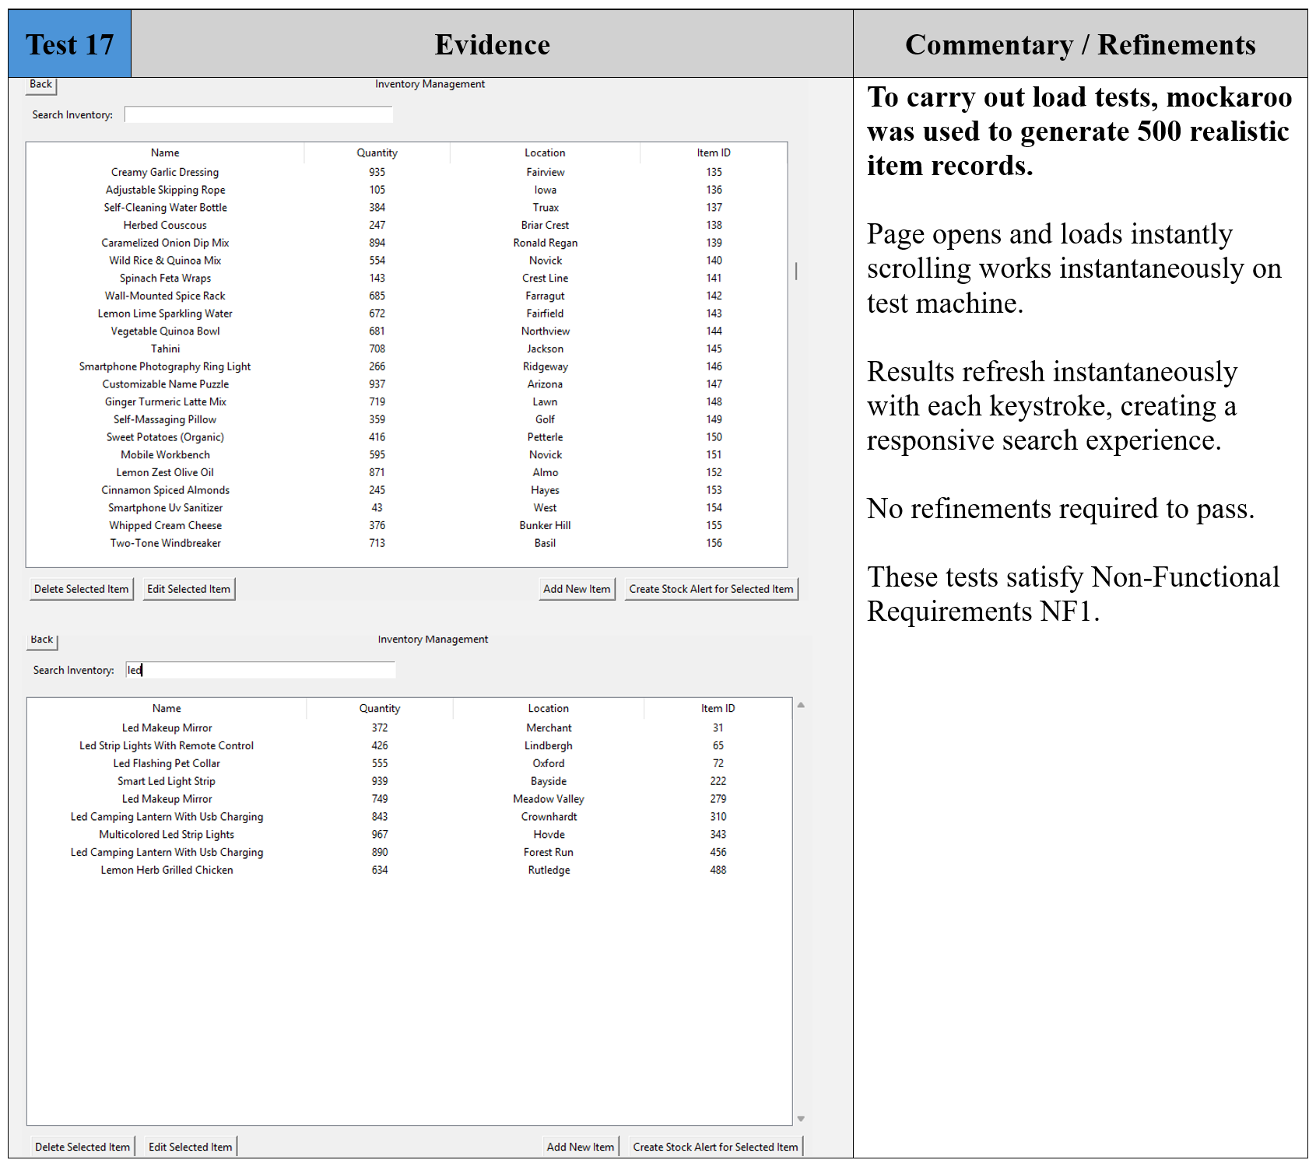

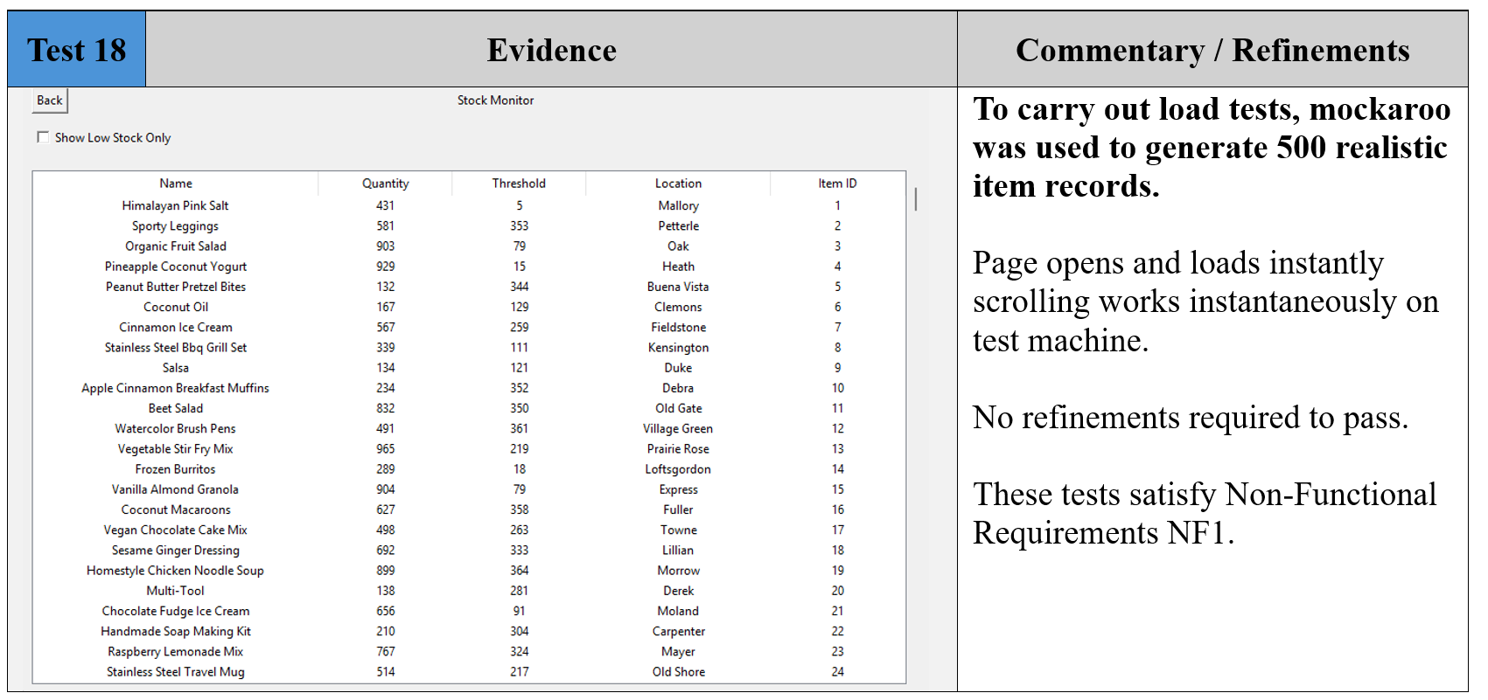

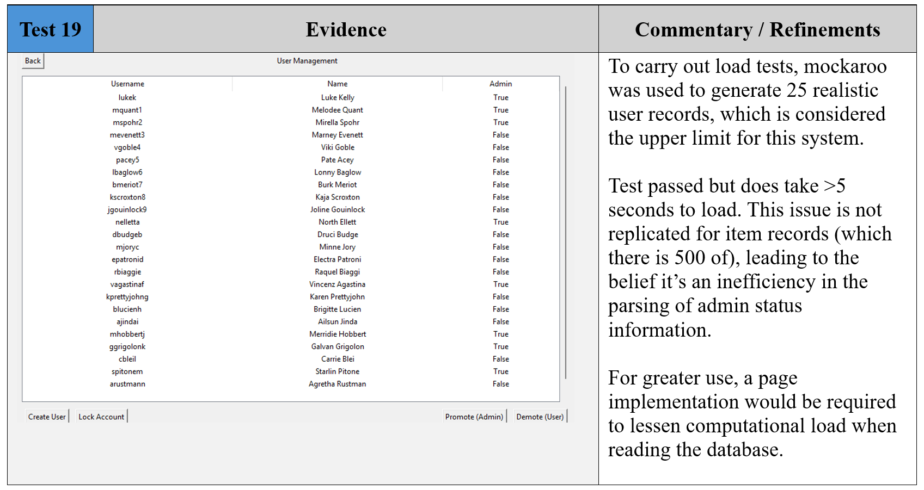

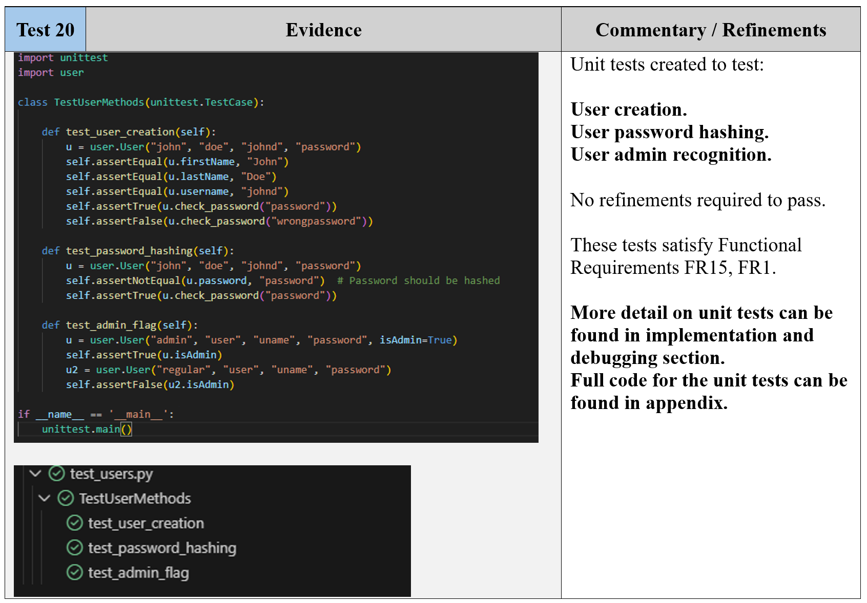

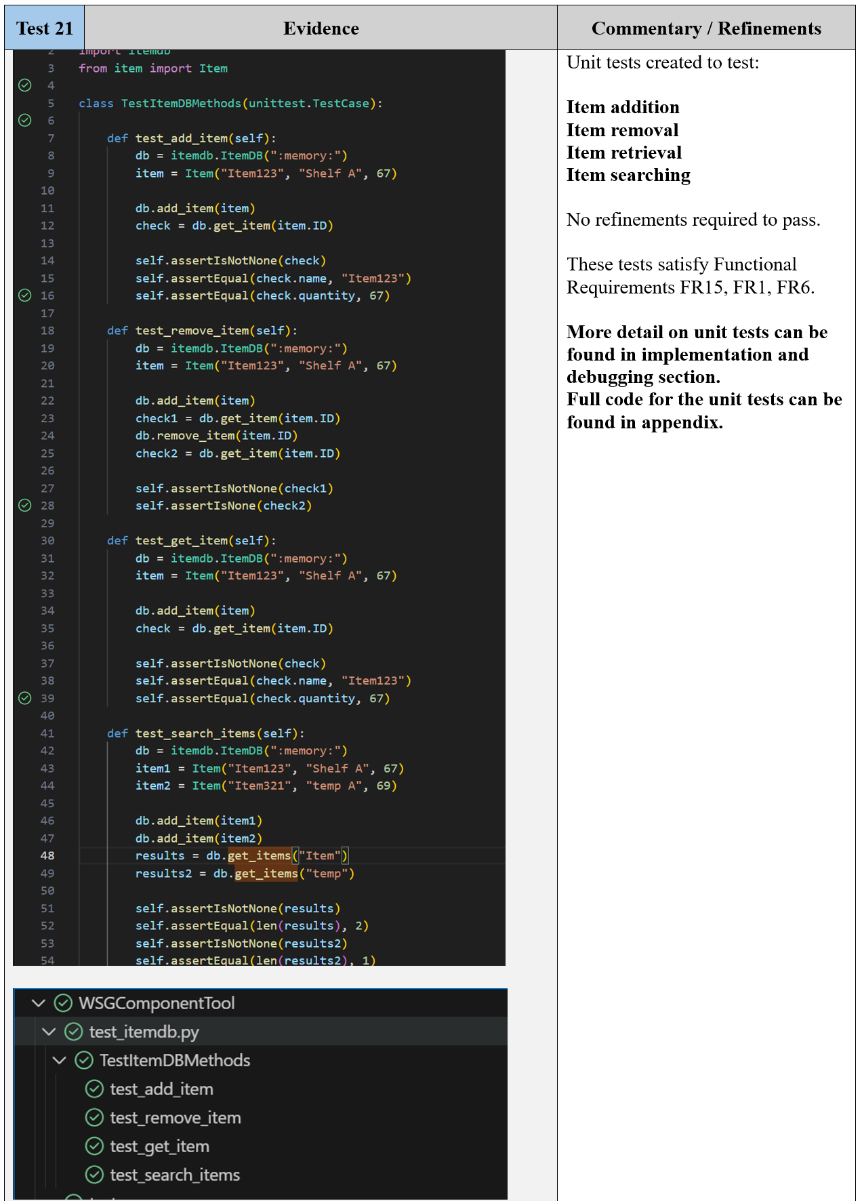

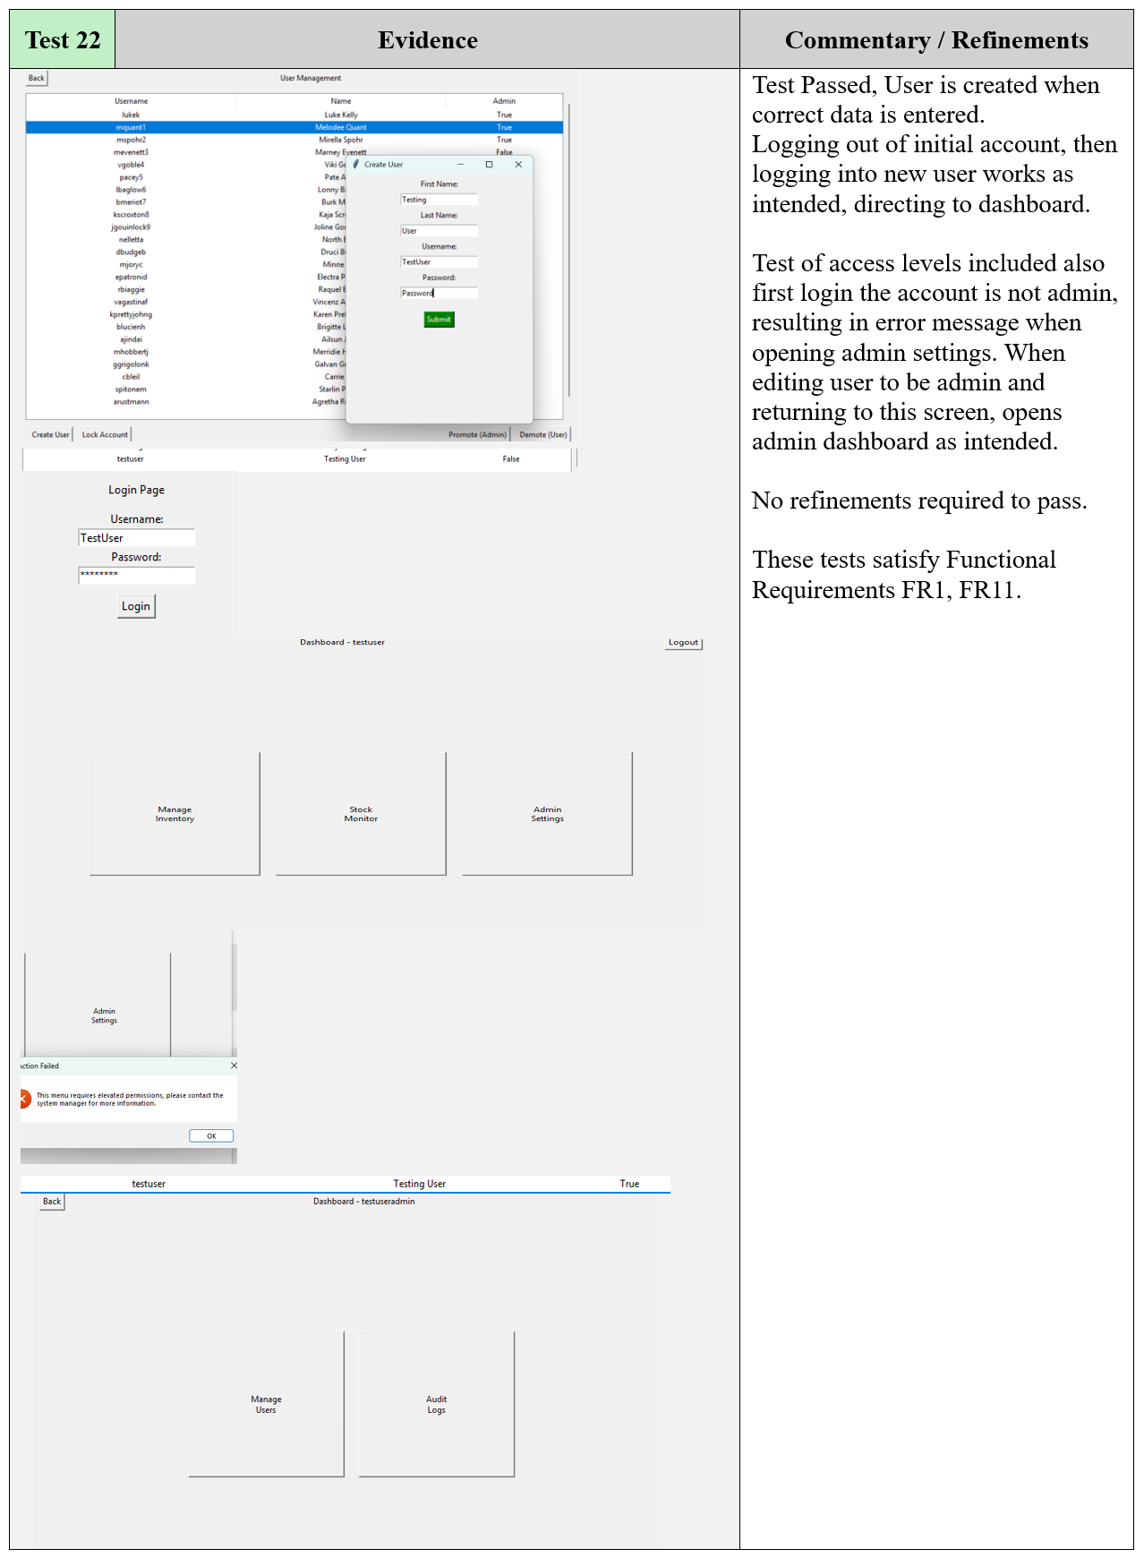

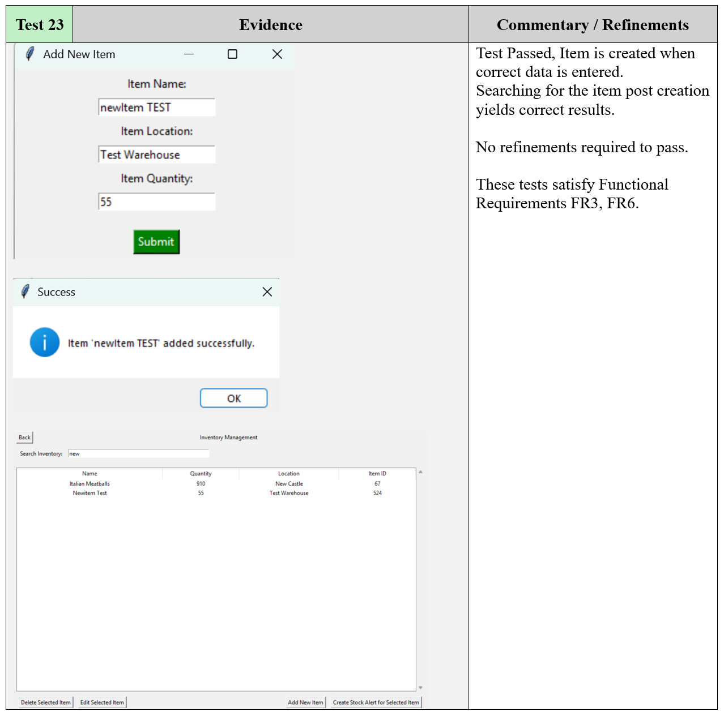

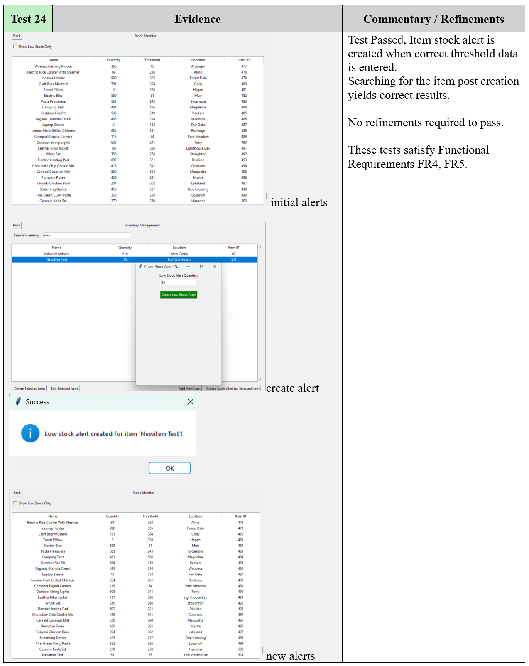

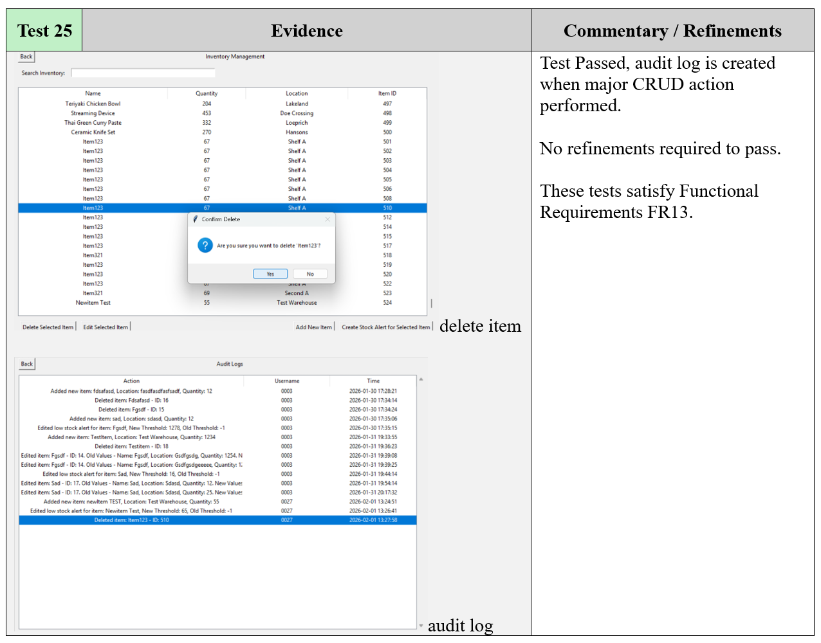

* 1. Development Testing

This section evidence tests where errors were encountered, alongside the debugging steps to resolve them.

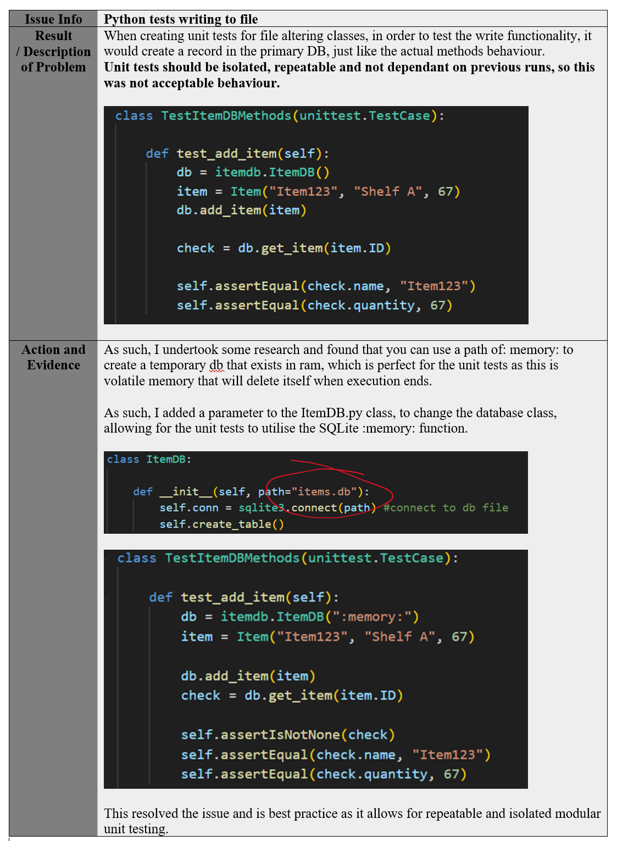

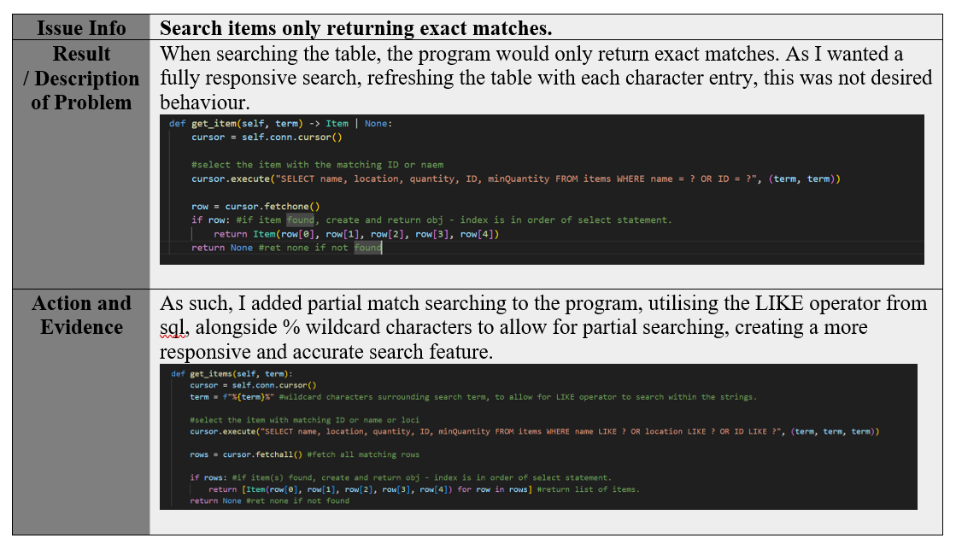

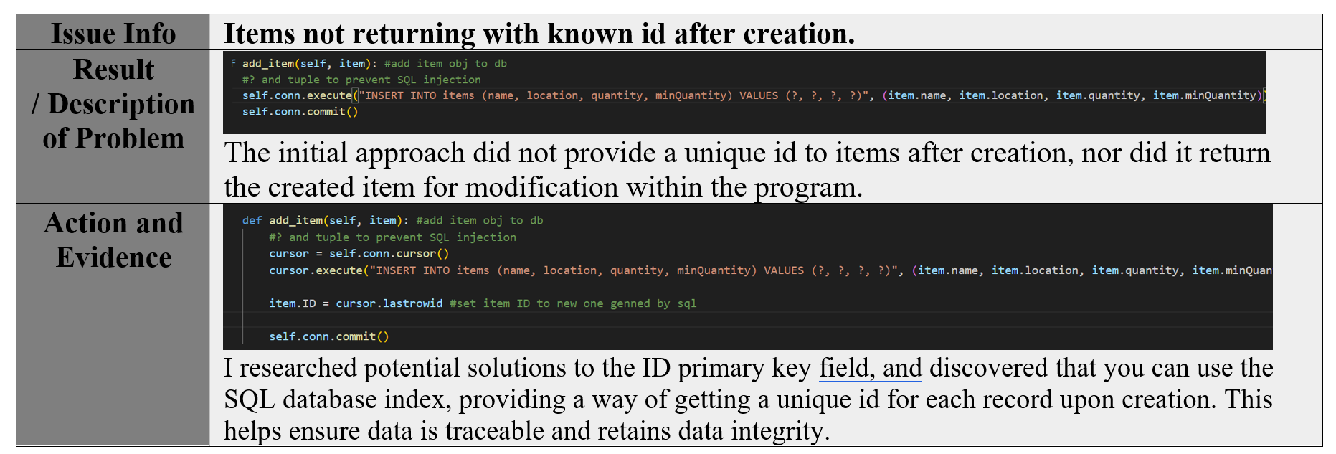

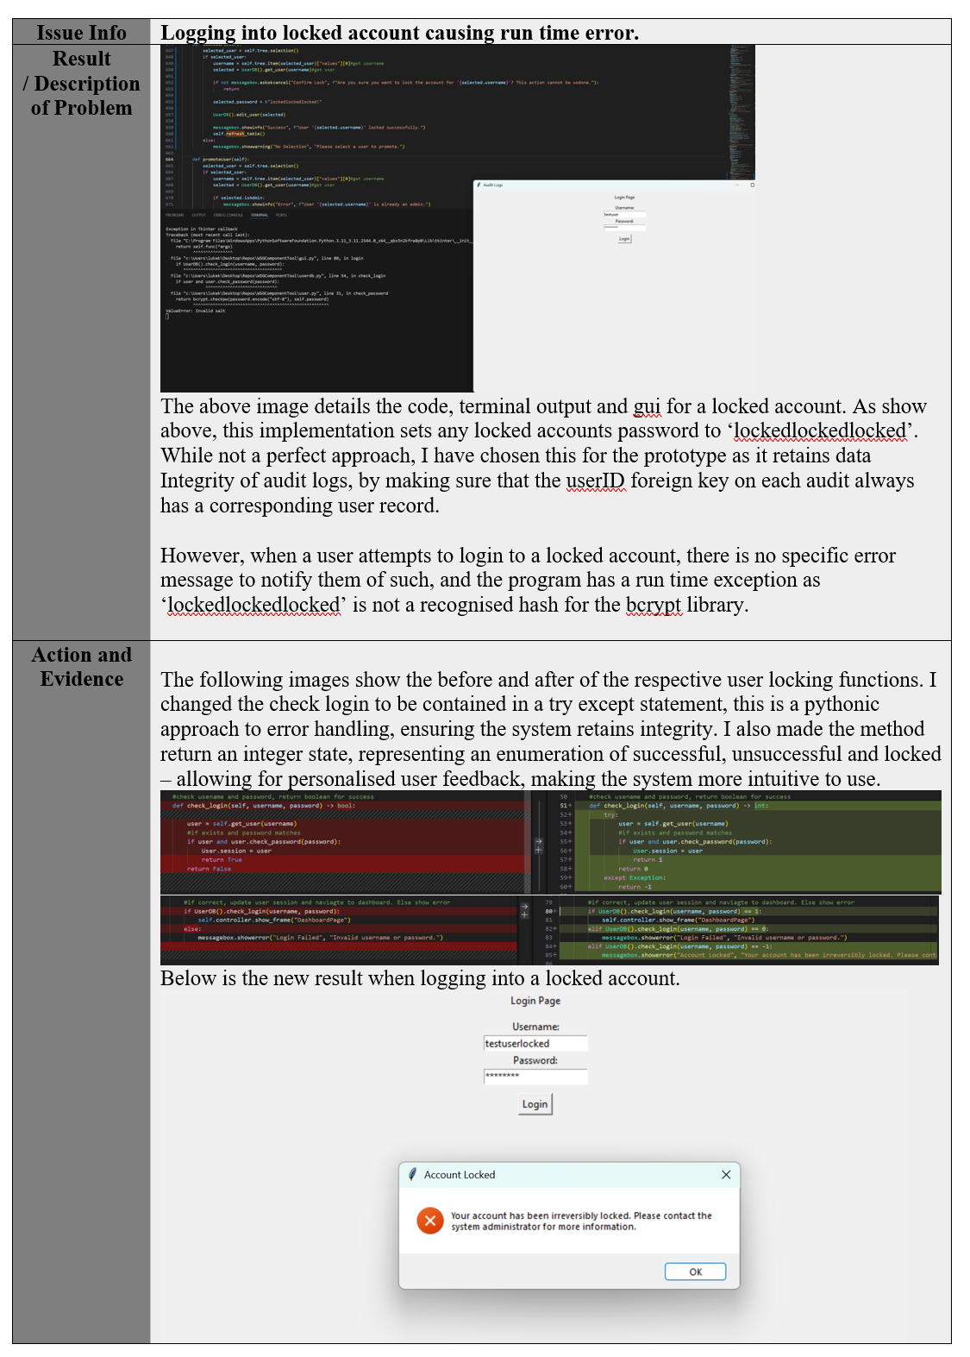

* 1. Debugging techniques

The general approach to debugging throughout the implementation is detailed above. Debugging primarily consisted of following subprogram return addresses in the first instance of an error and using print statements to inspect variables when issues occurred in areas with complex logic.

Testing was used extensively and is detailed fully in the tables in appendix E. Furthermore, the program utilised unit tests, allowing reproducible testing after each additional change to major file handling classes, helping ensure data integrity in the critical inventory system.

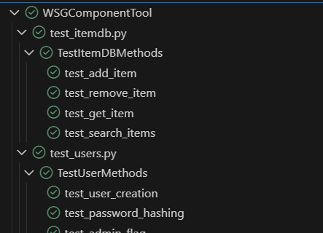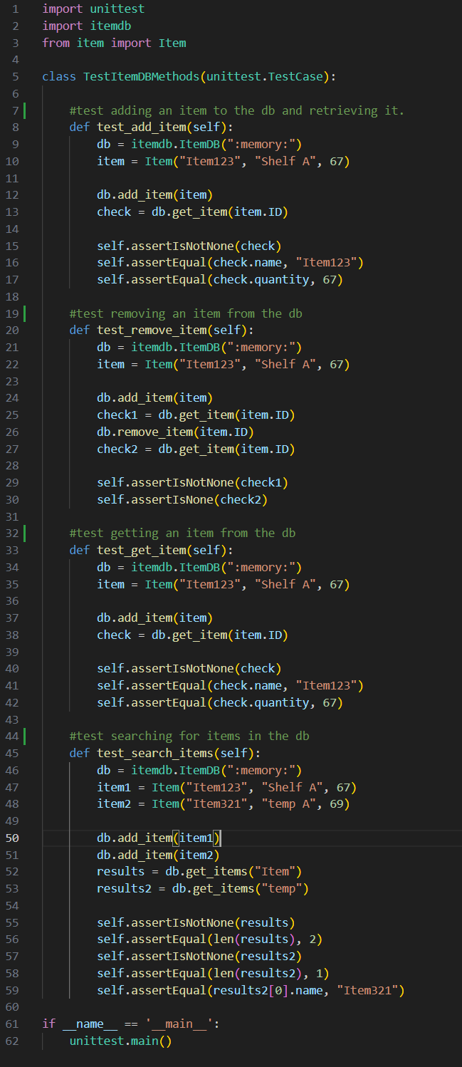Figures 5 and 6 detail the code behind one of the unit test files, and a demonstration of the visual studio code IDE marking the tests as successful.

Figures 5 and 6: visual studio IDE demonstrating unit tests.

* 1. Quality Control and Reliability

The functional testing outcomes demonstrate that the system meets it established functional and non-functional requirements. Input validation, controlled access levels, database abstraction and intuitive UI ensure reliable operation and strong data integrity. The modular class separation utilising OOP to separate GUI, logic and data layers allows for future modification and maintenance without massive overhead and risk.

The audit logging function enhances traceability within the company and allows managers to check for employees that are consistently inputting erroneous entries, to increase workforce skill through training, supporting operational reliability.

While the prototype is only demonstrative of single-machine deployment, the entire implementation and testing methodologies support future scalability through simple addition of further classes.

1. Evaluation and Reflection

The developed component management system meets the functional and non-functional requirements wholly. The layered architecture separating GUI, logic and database support modularity, maintainability, scalability and testability. The event driven and object-oriented approach lead to a modular final solution, allowing for easy unit testing and creating opportunity to add further functionality and a good skeleton to develop a non-prototype system from. The modelling of entities (users, items, audits) demonstrates abstraction and reduces system complexity, with separate database access classes for security, data integrity and reliability. This project has developed my understanding of the importance of industry standard practices like modular programming for all of the above reasons.

The solution is successful in its focus on data integrity and traceability. Secure authentication utilizes hashed credentials, strict input verification and audit logging ensure traceability and alignment with regulatory principles like GDPR. The GUI is intuitive and meets the nonfunctional requirements, and the system is extensively tested for resource usage, validation behaviour, and more with unit tests supported by the modular structure which can be re-used upon addition of new features.

However, due to the prototype scope, the system is designed for single machine deployment and does not support concurrent access or network operation. Furthermore, the GUI priorities function over form, and the use of SQLite would need considering before real world enterprise usage as it is intended for small workloads.

Further improvements could include adding server-side database support, enhancing role-based access and refining the GUI. Allowing for an intuitive system with many concurrent users. Further automation of testing and the utilisation of tickets on the GitHub repository would help support long term maintainability and reliability.

1. Appendix
   1. Appendix A – Stakeholder communications
      1. Assignment Brief

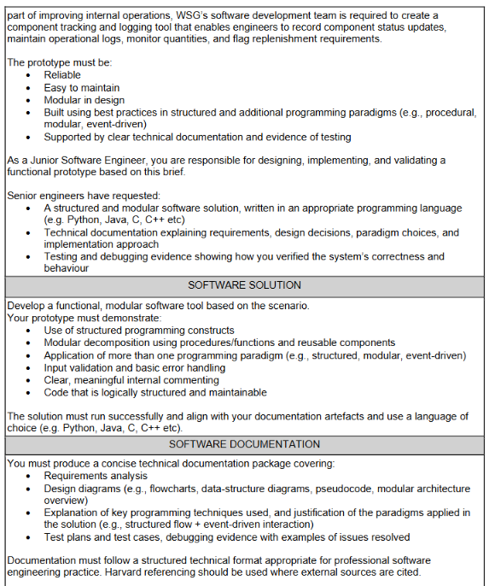

Appendix Figure 1: Assignment brief provided by WSG, acting as stakeholder input.

The above assignment brief was provided by WSG as a primary form of stakeholder input to aid the development of the prototype solution.

* 1. Appendix B – Source Code(s)
     1. Version control – GitHub repository

<https://github.com/character-limit/WSGComponentTool/>

* + 1. Version control – logs

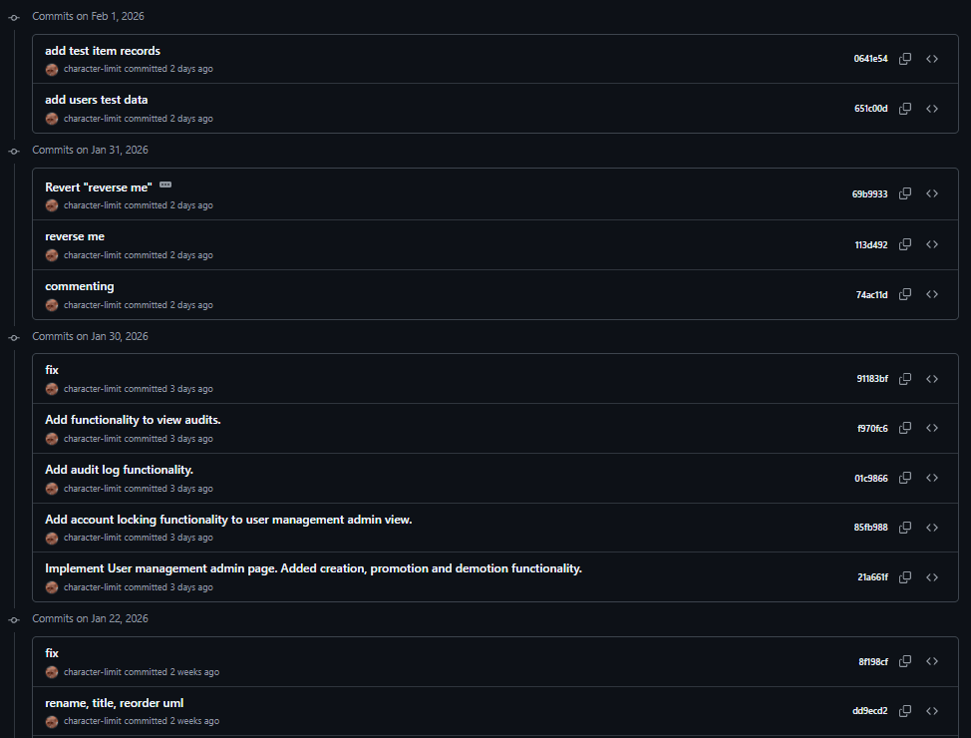

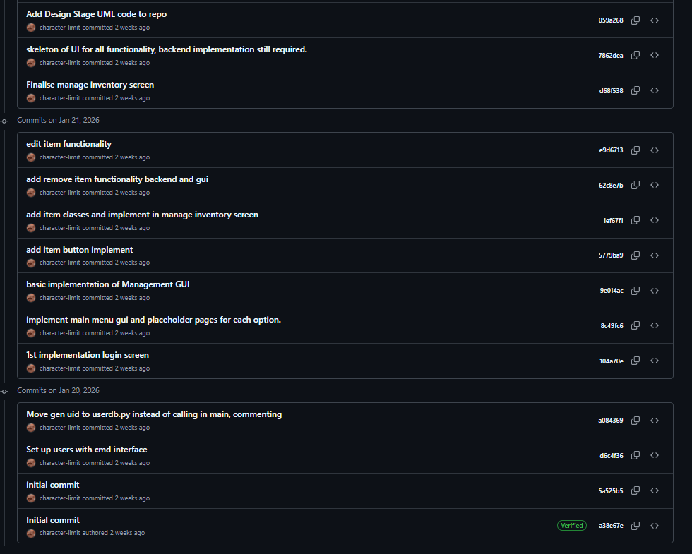

* + 1. Document Readme
    2. PlantUML class diagram source code

@startuml

package GUI {

    class App {

        -frames

        +show_frame(frame)

      }

    class LoginPage {

        +login()

        +exit()

      }

      class ManageUsersPage{

        +create_user()

        +lock_user()

        +edit_user(new_admin_status)

        +refresh_table()

        +back()

      }

      class InventoryPage {

        +search(term)

        +add_item()

        +delete_item()

        +edit_item()

        +create_alert()

        +refresh_table()

        +back()

      }

      class StockAlertPage{

        +refresh_table()

        +back()

      }

      class AuditPage{

        +refresh_table()

        +back()

      }

      class AdminDashboard{

        +open_users()

        +open_audit()

        +back()

      }

      class DashboardPage{

        +open_inventory()

        +open_stock_alerts()

        +open_admin_dash()

        +logout()

      }

}

package Logic {

    class Item {

        -name

        -location

        -quantity

        -ID

        -minQuantity

      }

    class User {

        -firstName

        -lastName

        -username

        -password

        -UID

        -isAdmin

        +check_password(pass)

      }

    class Audit {

        -actionDescription

        -UID

        -timeStamp

      }

    class ItemDB {

        +get_items()

        +search_items(term)

        +add_item(Item)

        +edit_item(Item)

        +remove_item(Item)

      }

    class UserDB {

        +get_user(UID)

        +check_login(username, password)

        +add_user(User)

        +edit_user(User)

        +remove_user(User)

      }

    class AuditDB {

        +get_audits()

        +add_audit(Audit)

      }

}

App -- LoginPage

App -- DashboardPage

App -- InventoryPage

App -- AdminDashboard

App -- AuditPage

App -- ManageUsersPage

App -- StockAlertPage

ItemDB --> Item

UserDB --> User

AuditDB --> Audit

AuditPage --> AuditDB

InventoryPage --> AuditDB

LoginPage --> UserDB

InventoryPage --> ItemDB

StockAlertPage --> ItemDB

ManageUsersPage --> UserDB

@enduml

* 1. Appendix C – GUI prototyping

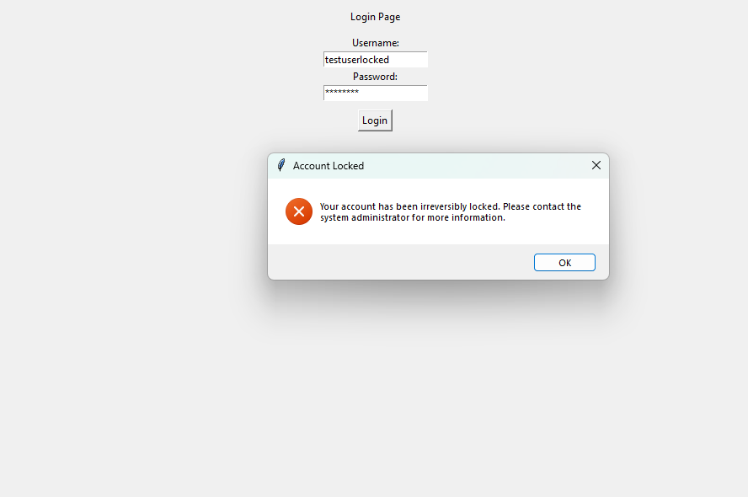

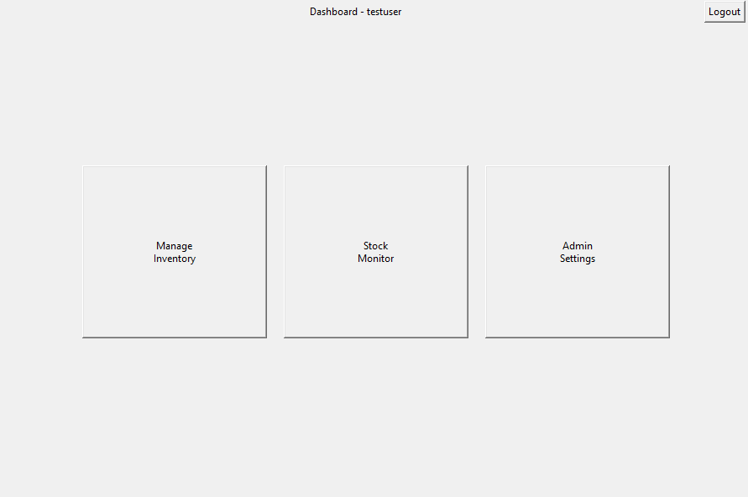

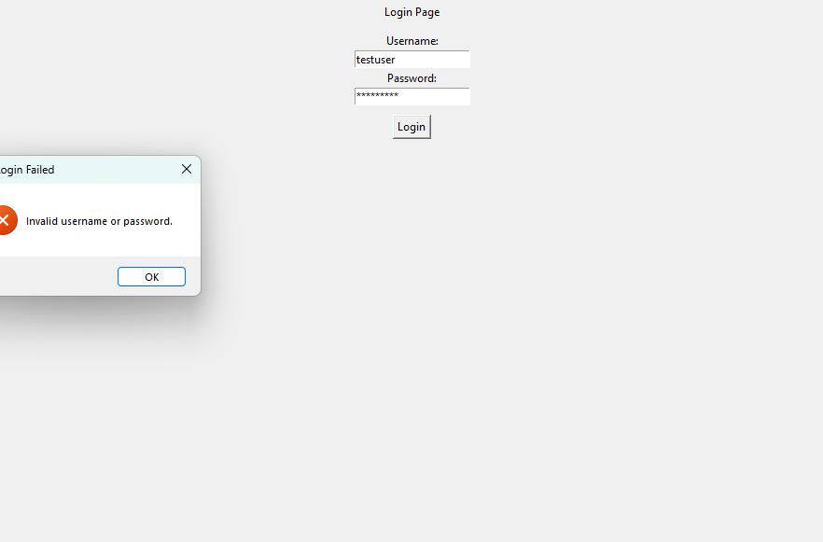

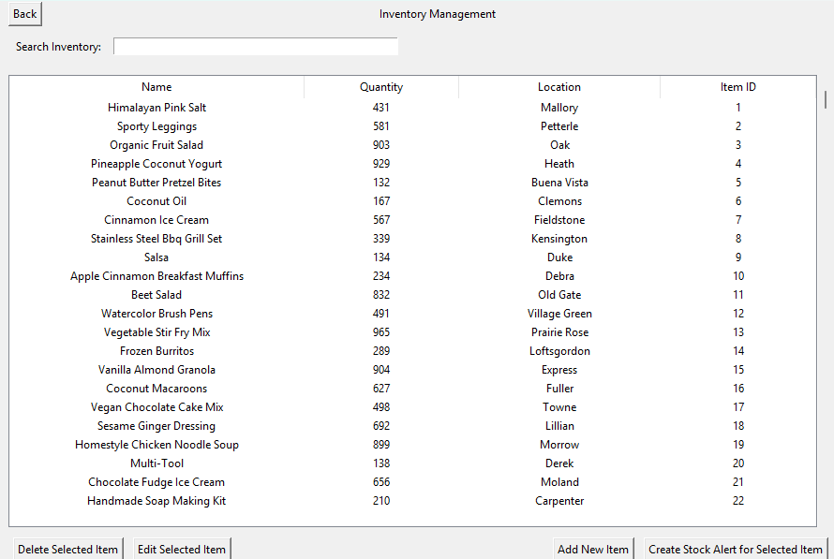

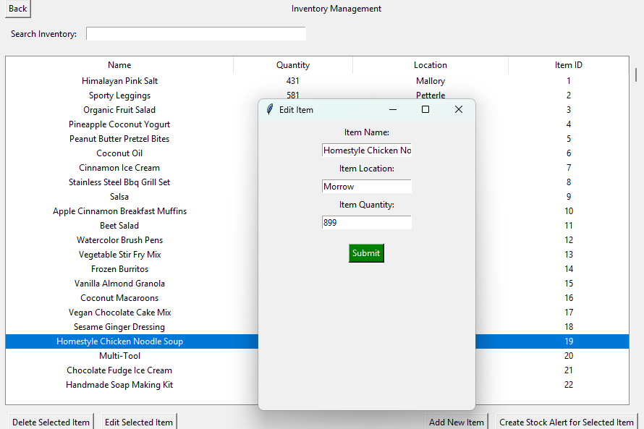

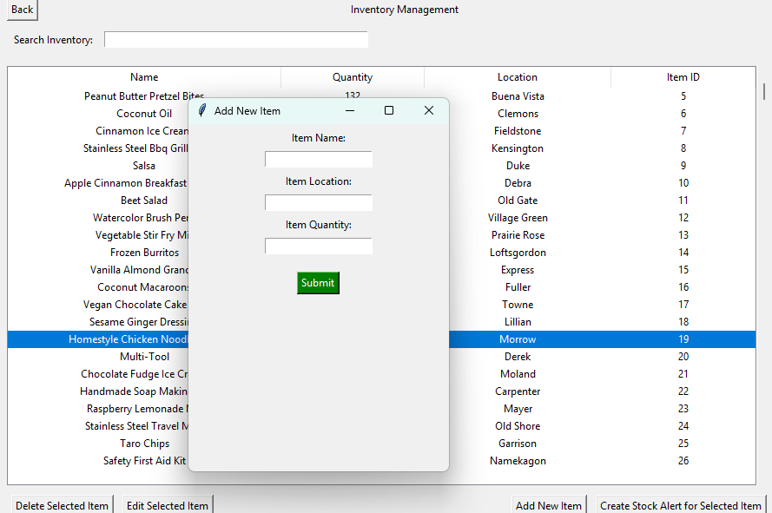

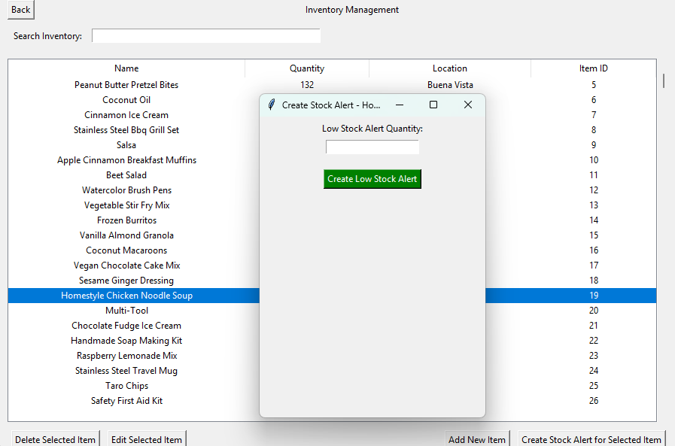

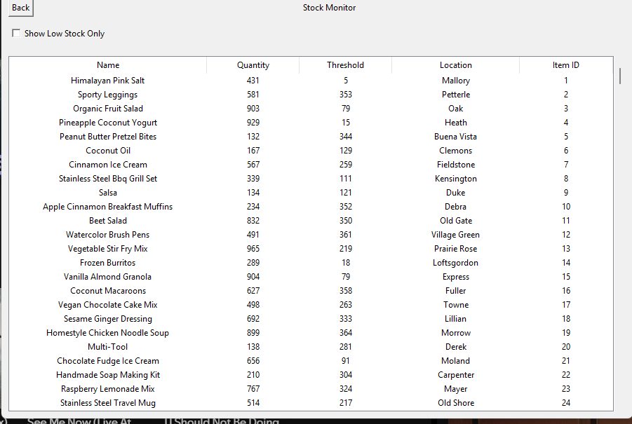

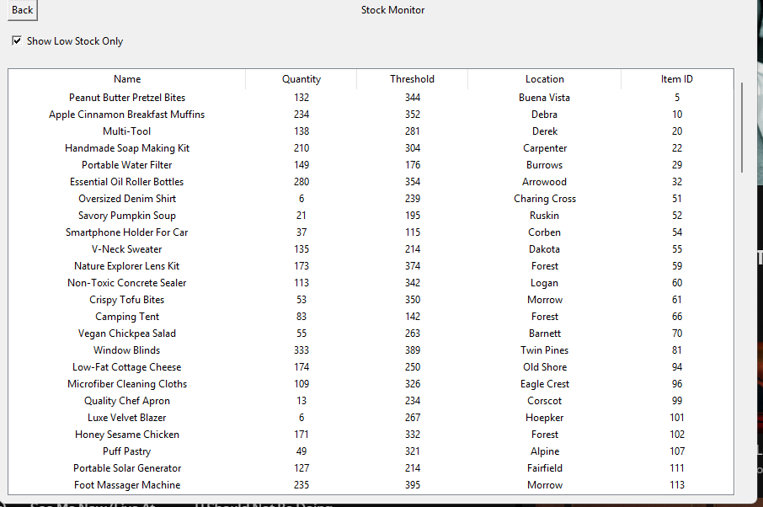

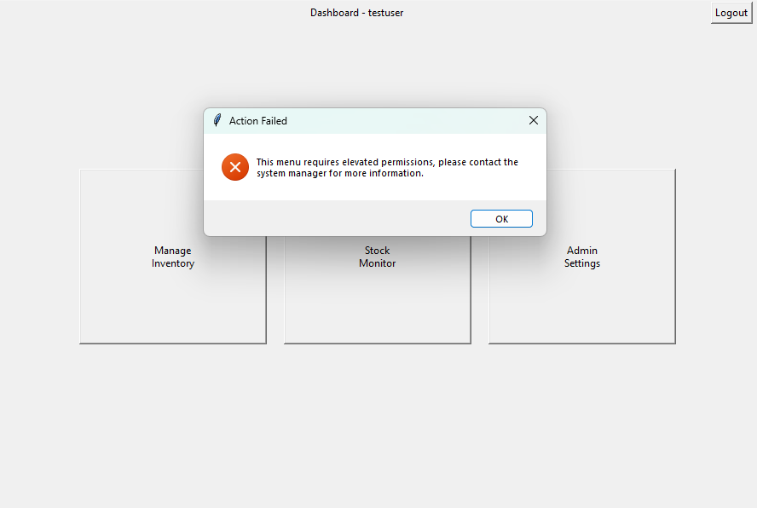

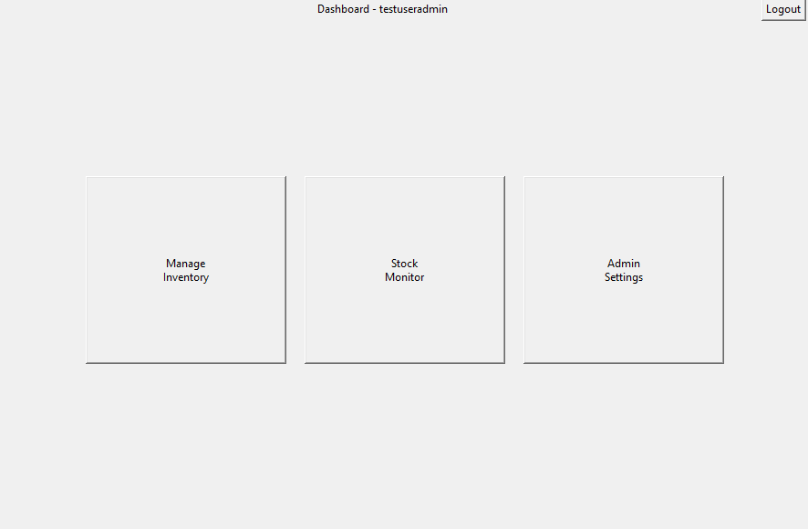

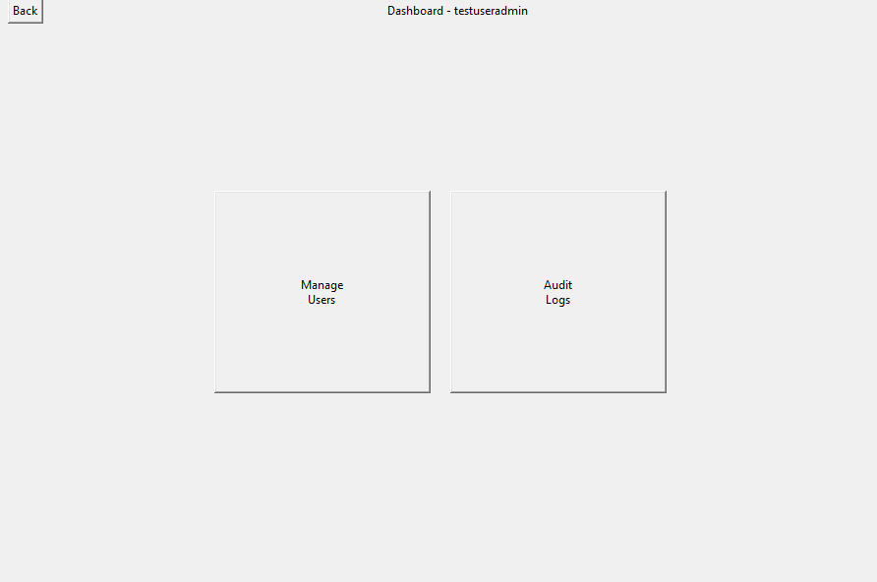

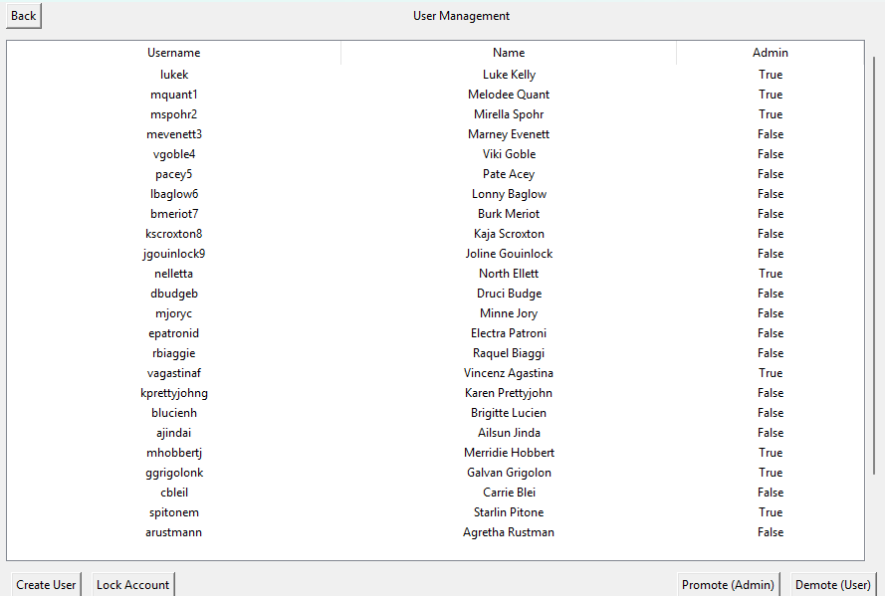

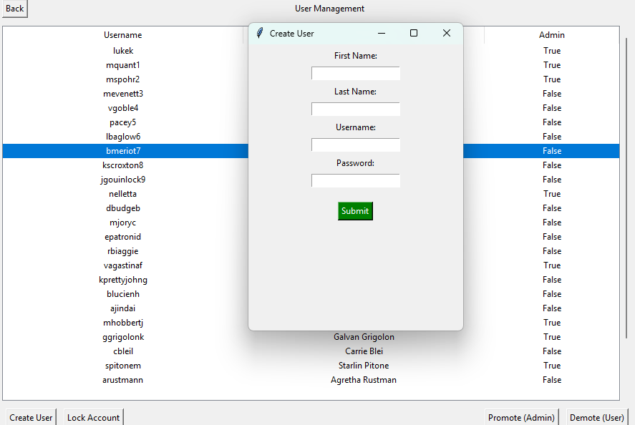

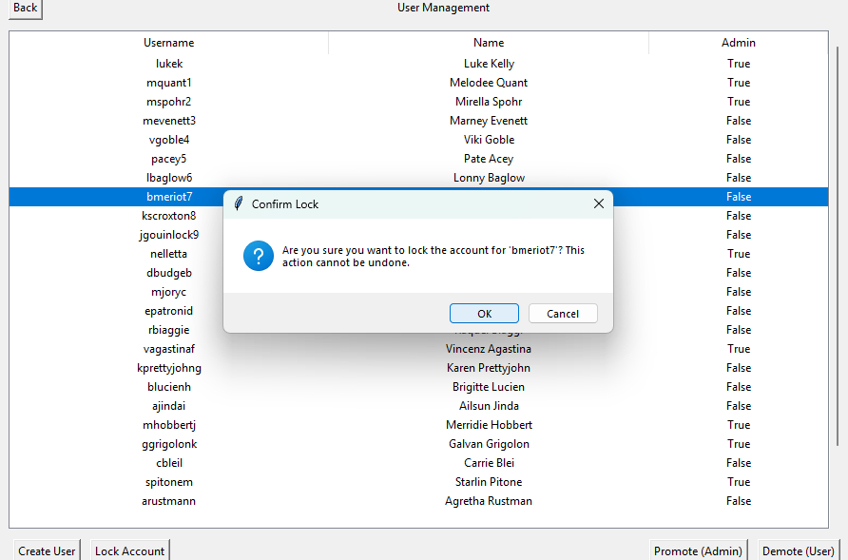

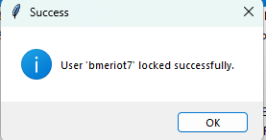

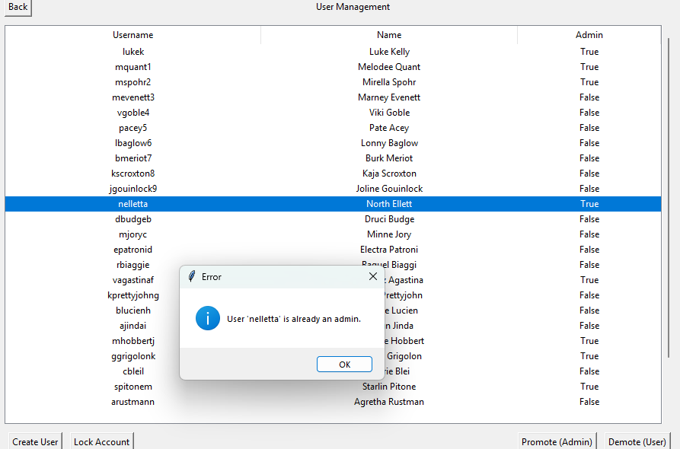

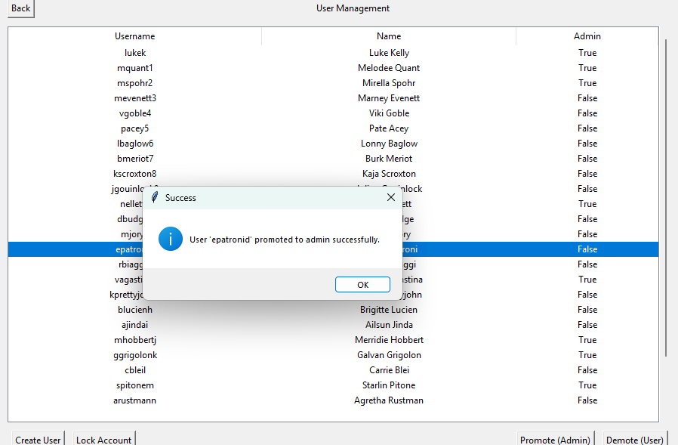

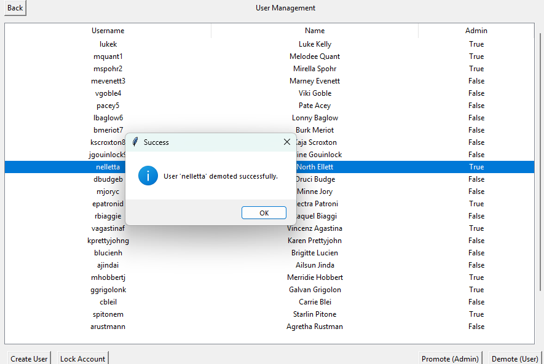

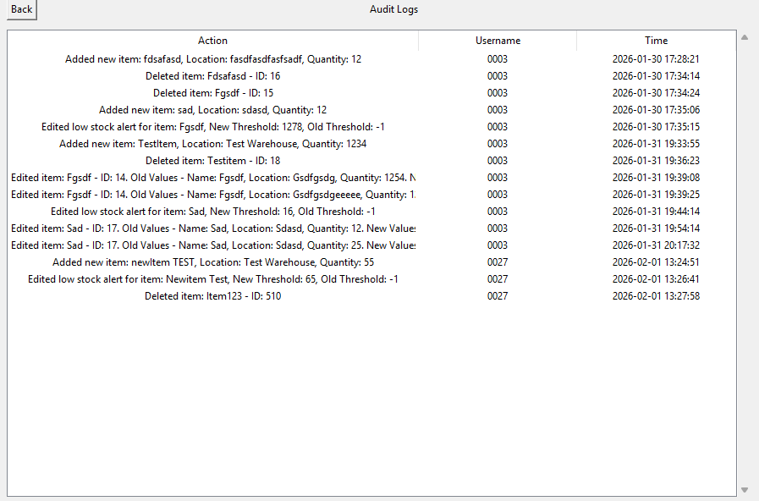

* 1. Appendix D – Further Documentation
     1. Code snippets against initial requirements.

Read/Write to database

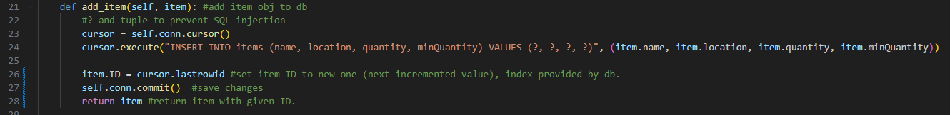

Figure 5: add_item function from itemdb.py

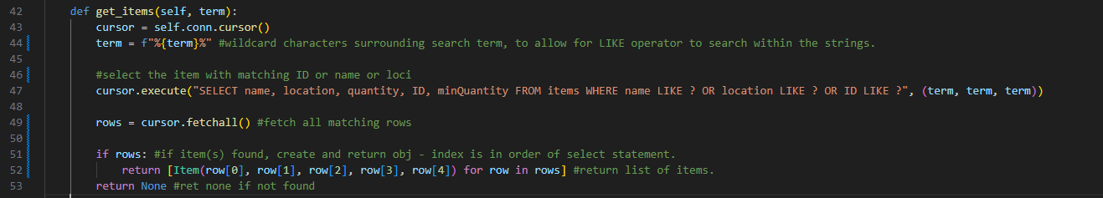

Figure 6: get_items function from itemdb.py

Figure 5 demonstrates the write item function. Figure 6 demonstrated the edit item function. All file handling uses the SQLite library, which is suited to the scale of this project over csv storage. Similarly to these examples, SQL queries are used for all file handling, for example in searching files. All file interactions begin with a function to create the sql table if it does not already exist, ensuring that the program errors gracefully and maintains data integrity.

**Covers: FR2, FR3, FR4, FR5, FR6, FR7, FR8, FR9, FR10, FR11, FR13, FR14, NF1, NF3, NF4, NF5.**

Authentication

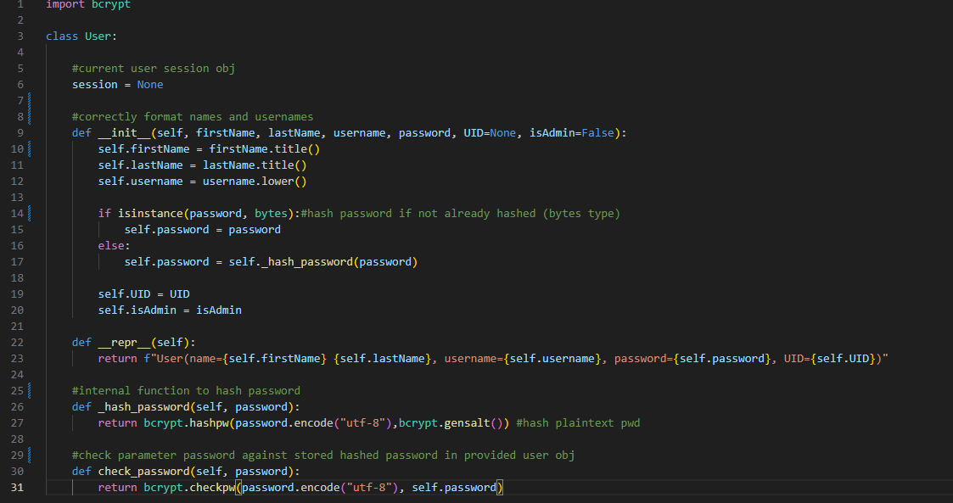

Figure 7: User class stored in user.py

Due to the nature of the business, it is important that the final system is secure. The program uses the bcrypt library to hash passwords, the benefits of this approach are detailed in section 3.2.2. When creating a user, the input is sanitised so that capitalisation is consistent across the system, aiding readability and ease of access. This ensures authentication is used to access private company information. The use of access levels also ensure that different views are provided to different levels of employees.

**Covers: FR1, FR8, FR10, FR11, FR12, FR15, FR16, FR17, NF3, NF4, NF5.**

Create audit log entry

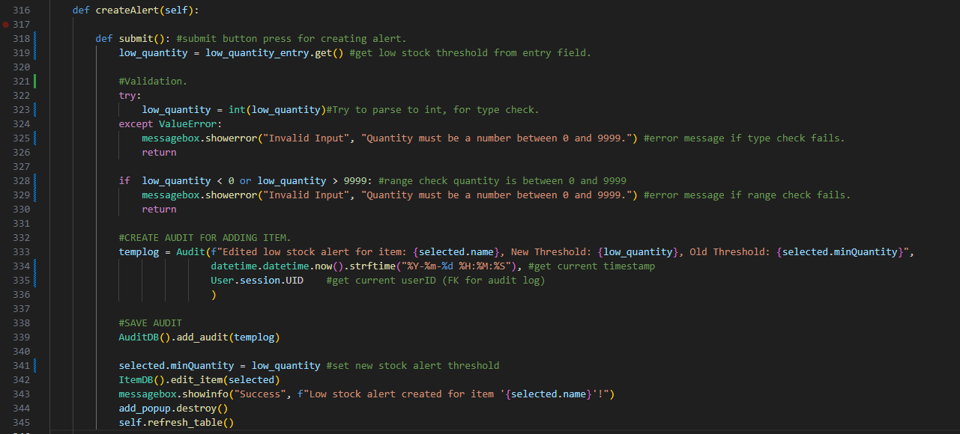

Figure 8: Create low stock alert method from GUI.py



Figure 7: add_audit method from auditdb.py

Figures 8 and 7 show the code for the creation of an audit log. It is called whenever a major CRUD action is performed in the system. This shows traceability for all user actions, should a manager/admin need to review this information.

Error handling and robustness

Code snippet + explain here (validation example).

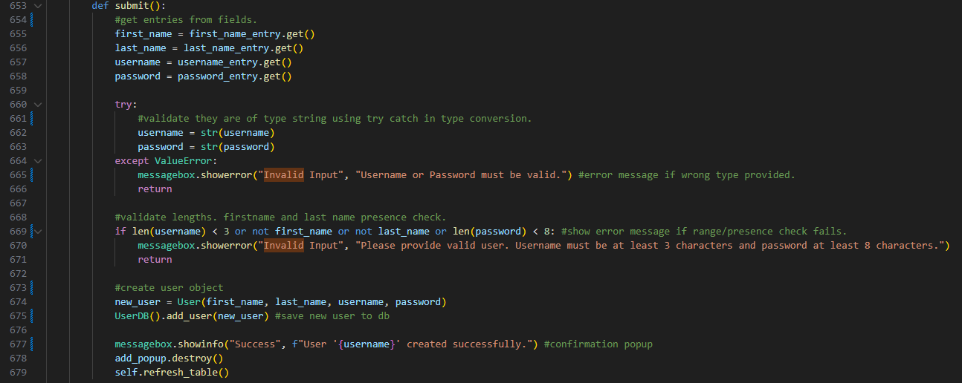

Figure 8: create user submit button even driven method from gui.py, demonstrating validation of strings.

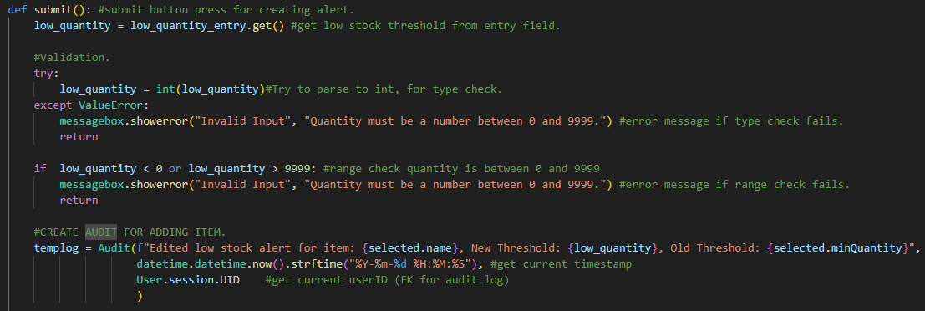

Figure 9: create low stock alert button even driven method from gui.py, demonstrating validation of numbers.

Due to the nature of the company, it is important that records are kept accurate and up to date to ensure regulatory compliance, as it is one of the main benefits of this system over the previously used paper records. The program is heavily validated, to ensure no run time errors that may lead to incomplete/corruption of the databases. Each field uses relevant range, presence and type checks (figure 8/9), and invalid entry will cause the program to notify and reprompt the user for entry. All levels of validation in the system ensure a robust, usable and secure system in real world applications.

**Covers: FR3, FR4, FR10, FR11, FR14, FR17, NF3, NF4, NF5**

* + 1. Use of Abstraction and Modelling

The system utilises abstraction to reduce code complexity, and as such improve readability and maintainability. For example, real world entities are modelled as objects, database operations are restricted to interface classes, GUI classes interact only with logic classes, and not with the implementation classes.

* + 1. Software Lifecycle Methodology

Waterfall principles were applied during the analysis and design to ensure stable requirements and traceability. However, a hybrid approach was taken from Implementation onwards to enable rapid prototyping and functional testing throughout the implementation. Balancing structured documentation requirements with rapid development and testing, reflecting real world professional practice for prototyping.

* 1. Appendix E – Textual Tables.
     1. Requirement Tables

Functional Requirements

|  |  |  |
| --- | --- | --- |
|  | Requirement Description | Success Criteria |
| **FR1** | Users shall authenticate using valid username and password. | Check Credentials against DB entry.  Proceed to dashboard if pass. |
| **FR2** | Authenticated users shall view items in the inventory database on the stock view page. | Items retrieved.  Items displayed correctly on stock page. |
| **FR3** | Authenticated users can add, edit and delete items on the stock view page. | CRUD operations update database.  Reflected immediately on interface. |
| **FR4** | Authenticated users can add low stock alerts to items. | Alert threshold updated for item in database. |
| **FR5** | Authenticated users can view low stock items on the low stock alert page. | Low stock items retrieved (<threshold).  Items displayed accurately on alerts page. |
| **FR6** | Authenticated users can search items | Search returns all matching results from database, update GUI immediately. |
| **FR7** | Items will be sorted on the low stock alerts page. | All low stock items retrieved displayed in date order, or otherwise. |
| **FR8** | Only admin users can open the admin dashboard. | Non-Admins get error message. |
| **FR9** | Admin users can view users in the admin dashboard. | All users from DB are loaded and displayed in table. |
| **FR10** | Admin users can edit users in the admin dashboard. (Promote, demote, lock) | Users DB is updated to reflect changes immediately. |
| **FR11** | Admin users can create users in the admin dashboard. | Users DB contains new user, that can authenticate immediately. |
| **FR12** | Only admin users can view the audit log from the admin dashboard. | Non-Admins get error message. |
| **FR13** | All user actions on the items database are recorded to the audit log. | Each operation produces username, timestamped entry in log database. |
| **FR14** | The full CRUD operations can be used on each database, without impacting integrity. | Database integrity is maintained fully with every operation. |
| **FR15** | Passwords are fully hashed upon user creation. | No plaintext passwords accessible in any part of system. |
| **FR16** | Hashed passwords can be checked but not retrieved. | Authenticated without exposing plaintext password. |
| **FR17** | All inputted values must be validated against suitability and datatype. | Invalid inputs are rejected, with descriptive error message. |

Table 1: Table detailing functional requirements.

Non-Functional Requirements

|  |  |  |
| --- | --- | --- |
|  | Requirement Description | Success Criteria |
| **NF1** | The software shall be efficient, ensuring time is not lost due to slow processing. | Any GUI action completes without noticeable delay under normal load. |
| **NF2** | The GUI shall be digestible and intuitive for all users. | Efficient GUI, which can be used without guidance. |
| **NF3** | All sensitive data within the software shall be hashed and stored securely. | Secure data is not stored in plaintext; access levels prevent access to sensitive data. |
| **NF4** | The software shall always produce consistent and reliable results. | Data integrity between normal execution cycles, and throughout CRUD operations. |
| **NF5** | The system shall be easily amendable. | Fully modular, maintainable structure. |

Table 2: detailing non-functional requirements.

Each requirement is given an ID, which is traceable to test cases, design decisions and validation evidence in the respective sections.

* + 1. Validation tables

Item

|  |  |  |  |  |
| --- | --- | --- | --- | --- |
| Field Name | Field type | Example Data | Validation Required | Validation type |
| ID | PK | 0001 | No |  |
| name | N/A | Bolt 16A | Yes | Length, type |
| location | N/A | Warehouse A | Yes | Length, type |
| quantity | N/A | 60 | Yes | Range, type |
| minQuantity | N/A | 30 | Yes | Range, type |

Table 3: Table detailing fields of class, and which fields require validation of input.

User

|  |  |  |  |  |
| --- | --- | --- | --- | --- |
| Field Name | Field type | Example Data | Validation Required | Validation type |
| UID | PK | 0001 | No |  |
| firstName | N/A | john | Yes | Length, type |
| lastName | N/A | doe | Yes | Length, type |
| username | N/A | john02 | Yes | Length, type, special characters |
| password | N/A | $2b$12$rR1nK6JvIWL84 | Yes | Length, type, special characters |
| admin | N/A | false | No |  |

Table 4: Table detailing fields of class, and which fields require validation of input.

* + 1. Testing Table

|  |  |  |  |  |  |
| --- | --- | --- | --- | --- | --- |
| Test # | Description | Checking for | Requirement Links | Expected Result | Result |
|  | Sign in | When a user signs in with correct login, directs them to the menu. | FR1 | Display Dashboard |  |
|  | Create Item | Create item using GUI, with correct entries. | FR3, FR14 | Create item, update database and table |  |
|  | Remove Item | Delete Item using GUI. | FR3, FR14 | Update database and table |  |
|  | Edit Item | Edit Item using GUI, with correct entries. | FR3, FR14 | Update database and table |  |
|  | Create Stock Alert | Set up minimum stock using GUI, with correct entries. | FR4 | Update database and table(s) |  |
|  | Admin – Create User | Create user using GUI, with correct entries. | FR11 | Update database, immediate reflection. |  |
|  | Admin – Edit User | Promote/Lock User using GUI, with correct entries. | FR10 | Update database, immediate reflection. |  |
|  | Sign in | When user signs in with incorrect login, error. | FR1 | Prompt re-entry |  |
|  | Create Item | Create new item with invalid quantity (twelve) | FR17 | Prompt re-entry |  |
|  | Edit Item | Edit item / Create stock alert with invalid quantity (twelve). | FR17 | Prompt re-entry |  |
|  | Create Item | Create new item with invalid quantity (-12) | FR17 | Prompt re-entry |  |
|  | Edit Item | Edit item / Create stock alert with invalid quantity (-12). | FR17 | Prompt re-entry |  |
|  | Create Item | Create new item with boundary quantity (-1) | FR17 | Prompt re-entry |  |
|  | Edit Item | Edit item / Create stock alert with boundary correct quantity (0). | FR17 | Update item. |  |
|  | Check user | Check ability to log in with high user count. | NF1 | Login in >1 second. |  |
|  | Display Inventory | Check ability to display inventory under load. | NF1 | Display in >1 second. |  |
|  | Search Inventory | Check ability to search inventory under load. | NF1 | Update table in >0.2 seconds. |  |
|  | Display low stock | Check ability to check low stock under load. | NF1 | Display in >1 second. |  |
|  | Display users | Check ability to display / edit users under load. | NF1 | Display in >1 second. |  |
|  | Unit tests for users.py | Check user functions like encryption work with no leaks. | FR15 | All unit tests for users.py pass. |  |
|  | Unit tests for itemdb.py | Check item functions like search work with no leaks. | FR6 | All unit tests for itemdb.py pass. |  |
|  | Create user and login | Check the two components work together | FR1, FR11 | Easy navigation and input |  |
|  | Create Item and search | Check the two components work together | FR3, FR6 | Easy navigation and input |  |
|  | Create stock alert and view alerts | Check the two components work together | FR4, FR5 | Easy navigation and input |  |
|  | Generate audit log | Check that when Inventory action performed, audit created. | FR13 | Audit log with correct action, user and timestamp. |  |

* + 1. Test result tables

|  |  |  |
| --- | --- | --- |
| **Test 1** | **Evidence** | **Commentary / Refinements** |
|  | | Test Passed, User is successfully signed in when an existing login is entered and are sent to the dashboard screen.  User login is reaffirmed with reflection in tooltip test highlighted in the images.  No refinements required to pass.  Incorrect login Functionality is verified in Test 8.  These tests satisfy Functional Requirement FR1. |



|  |  |  |
| --- | --- | --- |
| **Test 2** | **Evidence** | **Commentary / Refinements** |
|  | | Test Passed, Item is successfully created when valid data is entered and is written to file.  No refinements required to pass.  Incorrect Item Creation Validation Functionality is verified in Test 9.  These tests satisfy Functional Requirements FR3, FR14. |

|  |  |  |
| --- | --- | --- |
| **Test 3** | **Evidence** | **Commentary / Refinements** |
|  | | Test Passed, Item is successfully deleted is reflected in the database file.  No refinements required to pass.  This test satisfies Functional Requirements FR3, FR14. |

|  |  |  |
| --- | --- | --- |
| **Test 4** | **Evidence** | **Commentary / Refinements** |
|  | | Test Passed, Item is successfully edited when valid data is entered and is reflected in database file.  No refinements required to pass.  Incorrect Item Edit Validation Functionality is verified in Test 10,12.  These tests satisfy Functional Requirements FR3, FR14, FR17. |

|  |  |  |
| --- | --- | --- |
| **Test 5** | **Evidence** | **Commentary / Refinements** |
|  | | Test Passed, Item is successfully edited when stock alert is created and is reflected in database file.  No refinements required to pass.  Incorrect Item Edit for stock alert Validation Functionality is verified in Test 12.  These tests satisfy Functional Requirements FR3, FR14, FR17. |

|  |  |  |
| --- | --- | --- |
| **Test 6** | **Evidence** | **Commentary / Refinements** |
|  | | Test Passed, User is successfully created and is reflected in database file.  No refinements required to pass.  These tests satisfy Functional Requirements FR11. |

|  |  |  |
| --- | --- | --- |
| **Test 7** | **Evidence** | **Commentary / Refinements** |
|  | | Test Passed, User is successfully updated and is reflected in database file when promoted.  No refinements required to pass.  These tests satisfy Functional Requirements FR11. |

|  |  |  |
| --- | --- | --- |
| **Test 8** | **Evidence** | **Commentary / Refinements** |
| ”passwor” | | Test Passed, User is not signed in when incorrect password is entered.  No refinements required to pass.  These tests satisfy Functional Requirements FR1. |

|  |  |  |
| --- | --- | --- |
| **Test 9** | **Evidence** | **Commentary / Refinements** |
|  | | Test Passed, Item is not edited in when incorrect quantity is entered.  **Test data “twelve” selected as invalid datatype test.**    No refinements required to pass.  These tests satisfy Functional Requirements FR17. |

|  |  |  |
| --- | --- | --- |
| **Test 10** | **Evidence** | **Commentary / Refinements** |
|  | | Test Passed, Item is not created when incorrect quantity is entered.  **Test data “twelve” selected as invalid datatype test.**    No refinements required to pass.  These tests satisfy Functional Requirements FR17. |

|  |  |  |
| --- | --- | --- |
| **Test 11** | **Evidence** | **Commentary / Refinements** |
|  | | Test Passed, Item is not created when incorrect quantity is entered.  **Test data “-12” selected as invalid range test.**    No refinements required to pass.  These tests satisfy Functional Requirements FR17. |

|  |  |  |
| --- | --- | --- |
| **Test 12** | **Evidence** | **Commentary / Refinements** |
|  | | Test Passed, Item is not edited in when incorrect quantity is entered.  **Test data “-12” selected as invalid range test.**    No refinements required to pass.  These tests satisfy Functional Requirements FR17. |

|  |  |  |
| --- | --- | --- |
| **Test 13** | **Evidence** | **Commentary / Refinements** |
|  | | Test Passed, Item is not created in when boundary incorrect quantity is entered, and the reprompt window is displayed.  **Test data “-1” selected as invalid range test, on the boundary of zero.**    No refinements required to pass.  These tests satisfy Functional Requirements FR17. |

|  |  |  |
| --- | --- | --- |
| **Test 14** | **Evidence** | **Commentary / Refinements** |
|  | | Test Passed, Item is updated when boundary correct quantity is entered.  **Test data “0” selected as valid range test, on the boundary.**    No refinements required to pass.  These tests satisfy Functional Requirements FR17. |

|  |  |  |
| --- | --- | --- |
|  | **Evidence of dataset creation** | **Commentary / Refinements** |
|  | | **To carry out load tests, mockaroo was used to generate 500 realistic user records.** |

|  |  |  |
| --- | --- | --- |
| **Test 15** | **Evidence** | **Commentary / Refinements** |
|  | | To carry out load tests, mockaroo was used to generate 25 realistic user records, which is considered the upper limit for this system. For more use, things like cloud capability could be considered, and a page implementation would be required to lessen computational load when reading the database.  **Users able to log in instantly.** |

|  |  |  |
| --- | --- | --- |
| **Test 16** | **Evidence** | **Commentary / Refinements** |
|  | | **To carry out load tests, mockaroo was used to generate 500 realistic item records.**  Page opens and loads instantly scrolling works instantaneously on test machine.  No refinements required to pass.  These tests satisfy Non-Functional Requirements NF1. |

|  |  |  |
| --- | --- | --- |
| **Test 17** | **Evidence** | **Commentary / Refinements** |
|  | | **To carry out load tests, mockaroo was used to generate 500 realistic item records.**  Page opens and loads instantly scrolling works instantaneously on test machine.  Results refresh instantaneously with each keystroke, creating a responsive search experience.  No refinements required to pass.  These tests satisfy Non-Functional Requirements NF1. |

|  |  |  |
| --- | --- | --- |
| **Test 18** | **Evidence** | **Commentary / Refinements** |
|  | | **To carry out load tests, mockaroo was used to generate 500 realistic item records.**  Page opens and loads instantly scrolling works instantaneously on test machine.  No refinements required to pass.  These tests satisfy Non-Functional Requirements NF1. |

|  |  |  |
| --- | --- | --- |
| **Test 19** | **Evidence** | **Commentary / Refinements** |
|  | | To carry out load tests, mockaroo was used to generate 25 realistic user records, which is considered the upper limit for this system.  Test passed but does take >5 seconds to load. This issue is not replicated for item records (which there is 500 of), leading to the belief it’s an inefficiency in the parsing of admin status information.  For greater use, a page implementation would be required to lessen computational load when reading the database. |

|  |  |  |
| --- | --- | --- |
| **Test 20** | **Evidence** | **Commentary / Refinements** |
|  | | Unit tests created to test:  **User creation.**  **User password hashing.**  **User admin recognition.**  No refinements required to pass.  These tests satisfy Functional Requirements FR15, FR1.  **More detail on unit tests can be found in implementation and debugging section.**  **Full code for the unit tests can be found in appendix.** |

|  |  |  |
| --- | --- | --- |
| **Test 21** | **Evidence** | **Commentary / Refinements** |
|  | | Unit tests created to test:  **Item addition**  **Item removal**  **Item retrieval**  **Item searching**  No refinements required to pass.  These tests satisfy Functional Requirements FR15, FR1, FR6.  **More detail on unit tests can be found in implementation and debugging section.**  **Full code for the unit tests can be found in appendix.** |

|  |  |  |
| --- | --- | --- |
| **Test 22** | **Evidence** | **Commentary / Refinements** |
|  | | Test Passed, User is created when correct data is entered.  Logging out of initial account, then logging into new user works as intended, directing to dashboard.  Test of access levels included also first login the account is not admin, resulting in error message when opening admin settings. When editing user to be admin and returning to this screen, opens admin dashboard as intended.  No refinements required to pass.  These tests satisfy Functional Requirements FR1, FR11. |

|  |  |  |
| --- | --- | --- |
| **Test 23** | **Evidence** | **Commentary / Refinements** |
|  | | Test Passed, Item is created when correct data is entered.  Searching for the item post creation yields correct results.  No refinements required to pass.  These tests satisfy Functional Requirements FR3, FR6. |

|  |  |  |
| --- | --- | --- |
| **Test 24** | **Evidence** | **Commentary / Refinements** |
| initial alerts  create alert    new alerts | | Test Passed, Item stock alert is created when correct threshold data is entered.  Searching for the item post creation yields correct results.  No refinements required to pass.  These tests satisfy Functional Requirements FR4, FR5. |

|  |  |  |
| --- | --- | --- |
| **Test 25** | **Evidence** | **Commentary / Refinements** |
| delete item  audit log | | Test Passed, audit log is created when major CRUD action performed.  No refinements required to pass.  These tests satisfy Functional Requirements FR13. |

1. References

Daracan, V.S.L., Latayan, R.J.E., Padilla, C.L.D. and Young, M.N. (2020). *Designing an Inventory Database Software Suitable for Small Business*. [online] IEEE Xplore. doi:https://doi.org/10.1109/ICETAS51660.2020.9484166.

GDPR (2018). *General Data Protection Regulation (GDPR)*. [online] GDPR. Available at: https://gdpr-info.eu/.

Group, P. and Michelson, B. (2006). *Event-Driven Architecture Overview Event-Driven SOA Is Just Part of the EDA Story*. [online] Available at: https://complexevents.com/wp-content/uploads/2006/07/OMG-EDA-bda2-2-06cc.pdf.

Wegner, P. (1990). Concepts and Paradigms of Object-Oriented Programming. *ACM SIGPLAN OOPS Messenger*, [online] 1(1), pp.7–87. doi:https://doi.org/10.1145/382192.383004.

Yee, M.-H., Badouraly, A., Lhoták, O., Tip, F. and Vitek, J. (2019). *Precise Dataflow Analysis of Event-Driven Applications*. [online] arXiv.org. Available at: https://arxiv.org/abs/1910.12935.